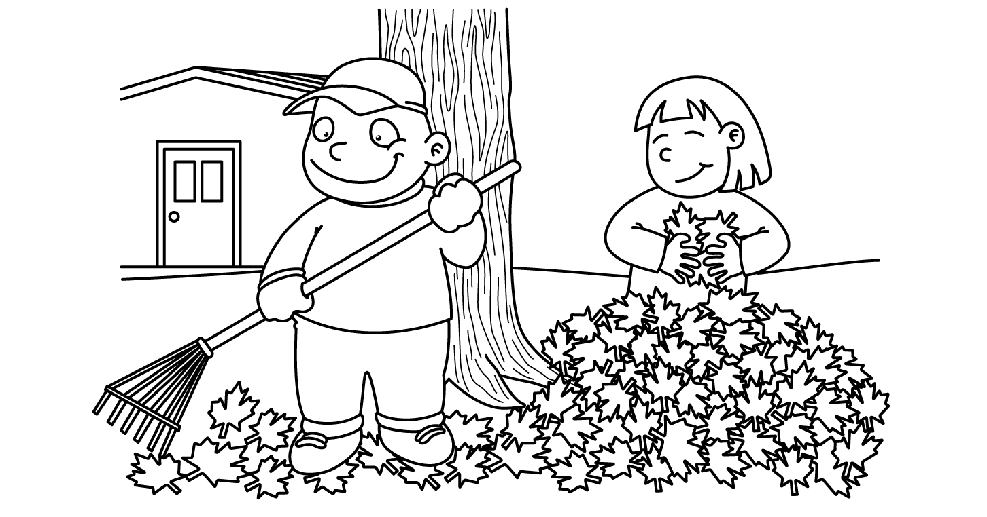

octobre (de 5 Robichaud)
dimanche | lundi | mardi | mercredi | jeudi | vendredi | samedi
22  Writing examples going home to be signed | 23 | 24 | 25  ½ Day for Students  Dimissal @11:30 | 26 | 27  Weekly Show What You Know | 28
29 | 30 | 31 | 1  Skating @8:40-9:40  Book Order  is due | 2 | 3  Weekly Show What You Know | 4
5 | 6  Construction of Rube Goldberg Machines begins | 7 | 8  Remembrance Day Concert for Students | 9  Weekly Show What You Know  Rube Goldberg Machines compete | 10  No School for Students | 11
12 | 13  No School | 14 | 15 | 16 | 17  Weekly Show What You Know | 18
*Please note: book orders can be placed at any time during the month but may be delayed if late etc.*
*To note: Parent-Teacher is the evening of Thurs, Nov 23 & the morning of Fri, Nov 24 (no school for students on the Friday).*

Reading
15 minutes EACH night. If you’ve misplaced your reading log calendar, simply write the name of the book title in your agenda and have your parents sign it (we will be doing this starting in the month of November).

Writing Samples
Writing Samples will be going home the week of October 23rd. Since students finish their good copies at different times, they will be sent home on different days. To note: about half will be sent home on the Monday. Please keep an eye.

Math Show What You Know Friday Quiz
This continue to be completed each Friday and sent home each Monday. Please review, sign and return every Tuesday.

Science
As a final element of our Simple Machines Unit, we will be create Rube Goldberg machines. Please save cardboard, small boxes, tubing etc to help your child in creating their machine.

Skating
Parents or a family representative are welcome to come skating with our class. Feel free to come tie skates, skate along with students or both! Students must wear a skating/hockey helmet. Bicycle helmets are not permitted.

Book Order
These can be given any time during the month. There is a $5 shipping charge for orders under a certain amount. Therefore, we try to group them together. Our next book order will be due November 1st.

