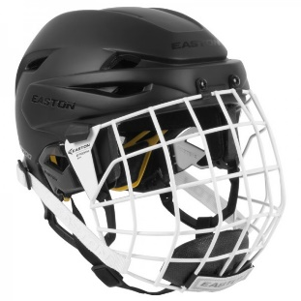
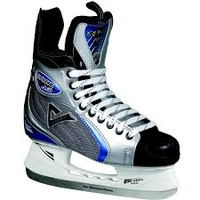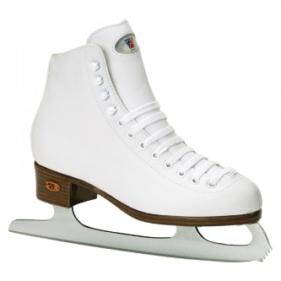
Grade 5 Skate Times
Wed., Nov 8 (rescheduled to Nov 1st, see below)

Wed., Dec 6 8:45-10:30 a.m.

Wed., Jan. 17 8:45-10:30 a.m.

Wed., Feb. 14 8:45-10:30 a.m.

Wed., March 21 8:45-10:30 a.m.

Our Grade 5 classes were scheduled to go skating on Wednesday, November 8th. Due to it being our Remembrance Day Concert, the date has changed to Wednesday, November 1st at the LBA.
8:40-9:40am = Grade 3 classes, 5 Richardson & 5 Robichaud
9:30-10:30am = Grade 4 classes, 5 McFarlane & 5 Glazier
Please ensure that your child brings their skates and a proper skating helmet (sorry bike helmets are not permitted). For safety reasons, students must wear skates and a helmet, or they will not be permitted on the ice.
Thank you,
From your favourite Grade 5 teachers

We love volunteers! Dig out your skates, come tie a few and join us.
-------------------------------------------------------------------------------------------

Child’s name: ____________________

My child needs to borrow skates ____ yes ____no.

My child needs to borrow a helmet ____ yes ____no.

