Numeracy/Maths

Choose one or two activities from each category in this order each day.
Warm Up – songs counting on youtube, skip counting orally by 2s to 20, 5s and 10s up to 100
Videos- Alain le lait, counting 1-100, 1-50, FouFou chanel addition, soustraction
Practice- write out the digits from 1-50, practice writing the numbers in words (1-20), representing numbers with tally marks then count by 5s, drawings/objects in groups of 2s, 5s then count them out orally
Websites can be found under the Website Tab on the Teacher Page, ixl website, Radio Canada Jeunesse, Math Playground
Hands On/ Games- number chart 1-100, find the missing number in the hundreds chart, concretely showing skip counting by 2s, 5s
- Ixl.com – Click on Grade 1 Math and focus on concepts Counting and Number Patterns: A.9-A.15 for this week and practice a few each day
Addition and subtraction facts up to 20. You can use household objects for counting and practicing the operations of adding and subtracting on paper as well.
- When you go to this website: Click on More… ,Online Math Games, Number Race https://lou1fi.weebly.com
- Try out these questions.
- Make up your own pictures and questions, then answer: How many?
Combien?
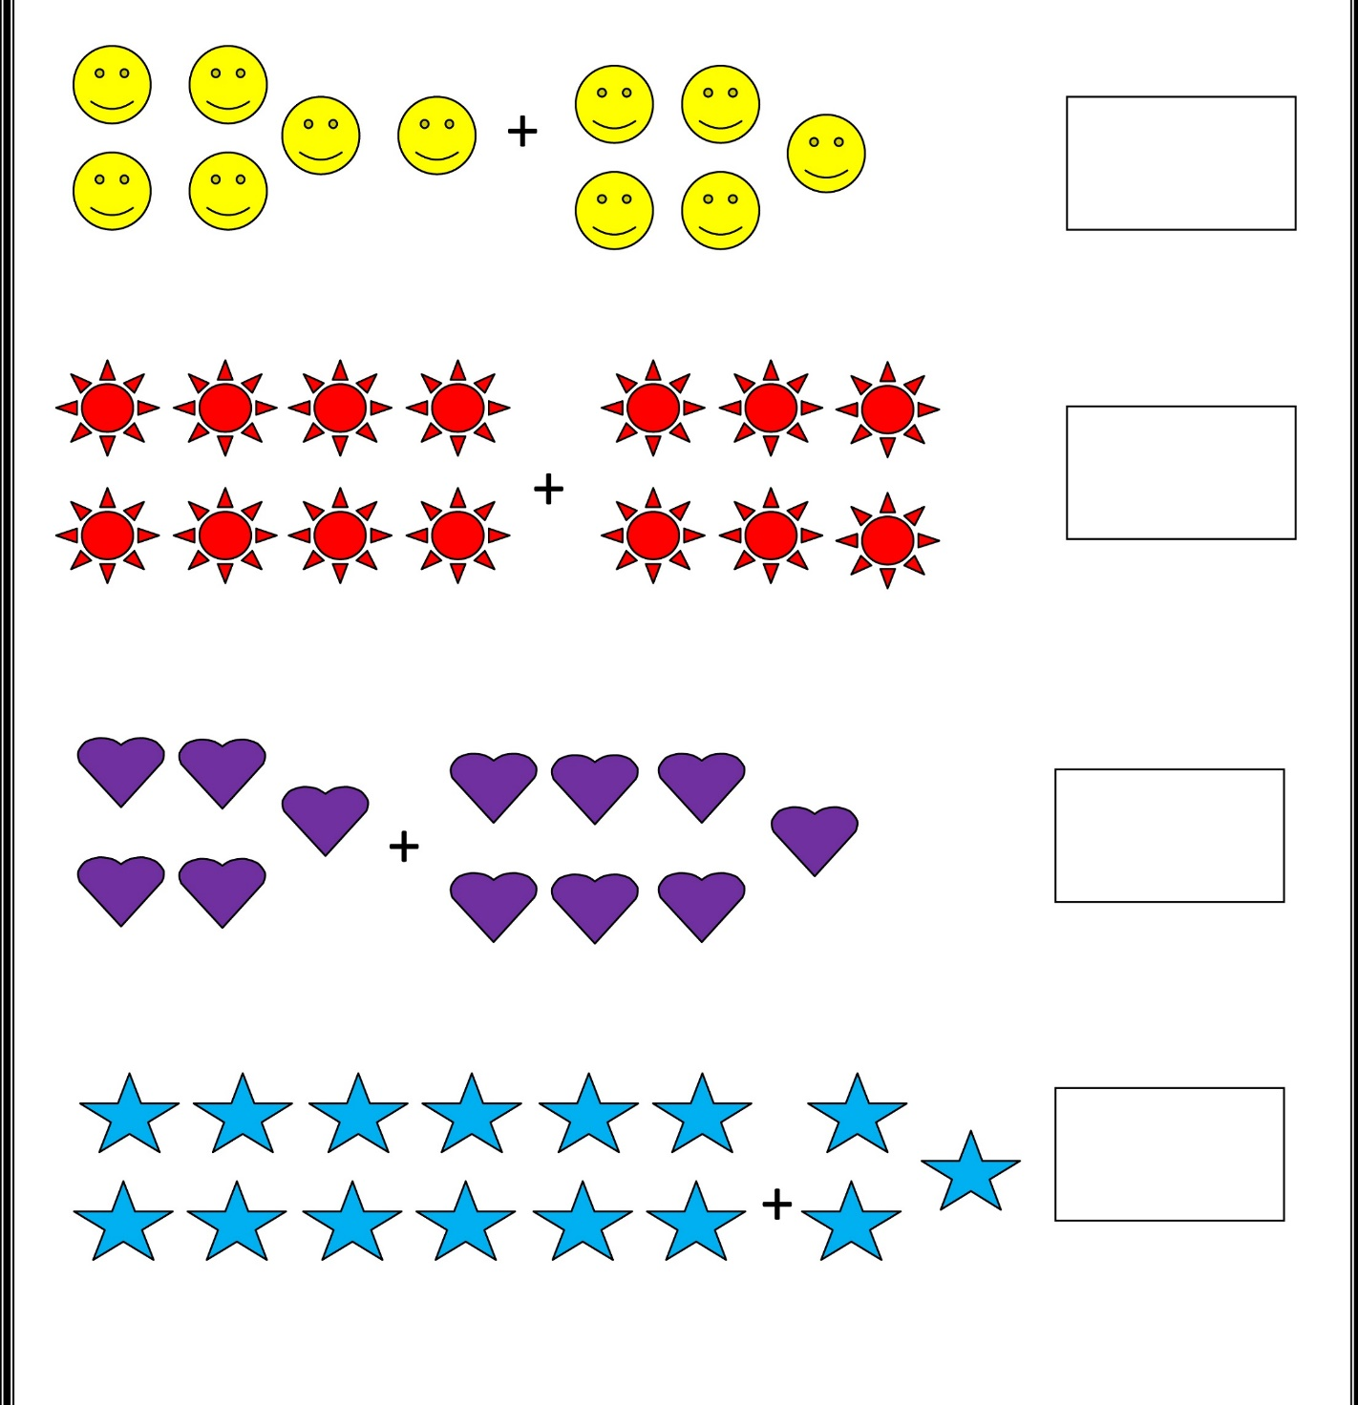
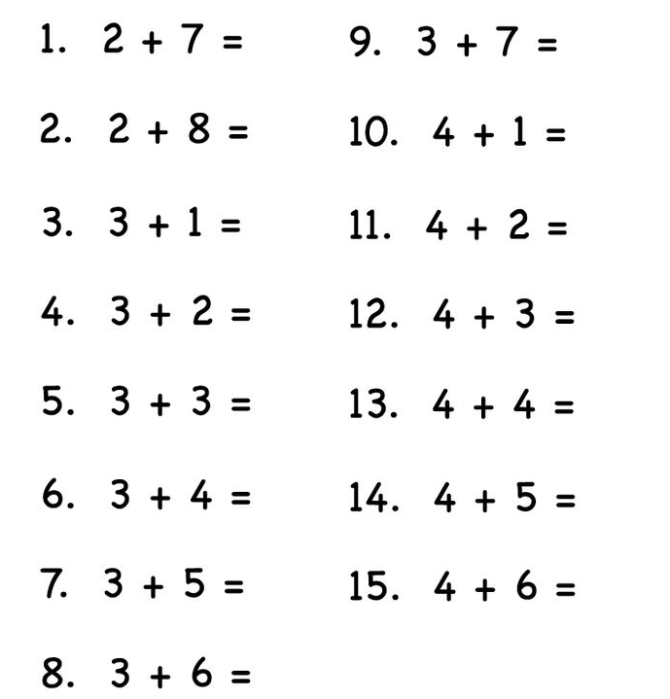

Hundreds Chart
