Monday, April 6 – Friday, April 10

Each day……
Listen to a Story Read a Story
or 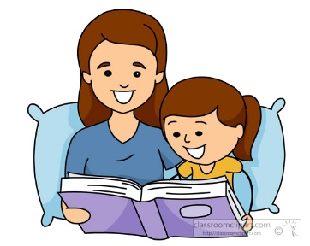 or
https://www.storylineonline.net Have an adult http://kidsa-z.com Read a book
read to you. from home.

What was your story about? Don’t forget to review your sight words.

Writing Math
Write a story of your choice or write about… Count to 100
100
https://www.youtube.com/watch?v=1dkPouLWCyc
Practice adding/subtraction
your family or your favourite food

Don’t forget capitals, spacing, periods and details. https://www.abcya.com/games/math_facts_game

