Home Learning: April 20th -24th
Hi boys and girls! This is our 3rd week of Home Learning and I know you are all trying hard and doing the best that you can. Don’t forget that it is very important to get outside for some fresh air and to do some physical activity. You can check out Mr. Williston’s teacher page for some suggested activities. Also, there is always the STEAM site with some challenging and fun activities as well. Here are some at home learning activities for this week:

Math: continue working on the math site: iknowit.com (found in the web link section).
This week we will be examining how to make a bar graph. We did create bar graphs in class before and just after our March Break.
Video: https://www.mathplayground.com/video_bar_graphs.html
Math Game: http://www.learnalberta.ca/content/me3us/flash/ Click on Data Management and play the game Using Bar Graphs

Task: Using the data you collected from the Measuring Snow activity you will create a bar graph. If you did not get a chance to collect data on your own, you can use my data to create your graph.
Here is my data: How Deep is the Snow
Date Measurement
March 31st 16 cm
April 1st 22 cm
April 2nd 13 cm
April 3rd 5cm
April 4th 2 cm
*** Here is my graph. Let’s see if you can create one.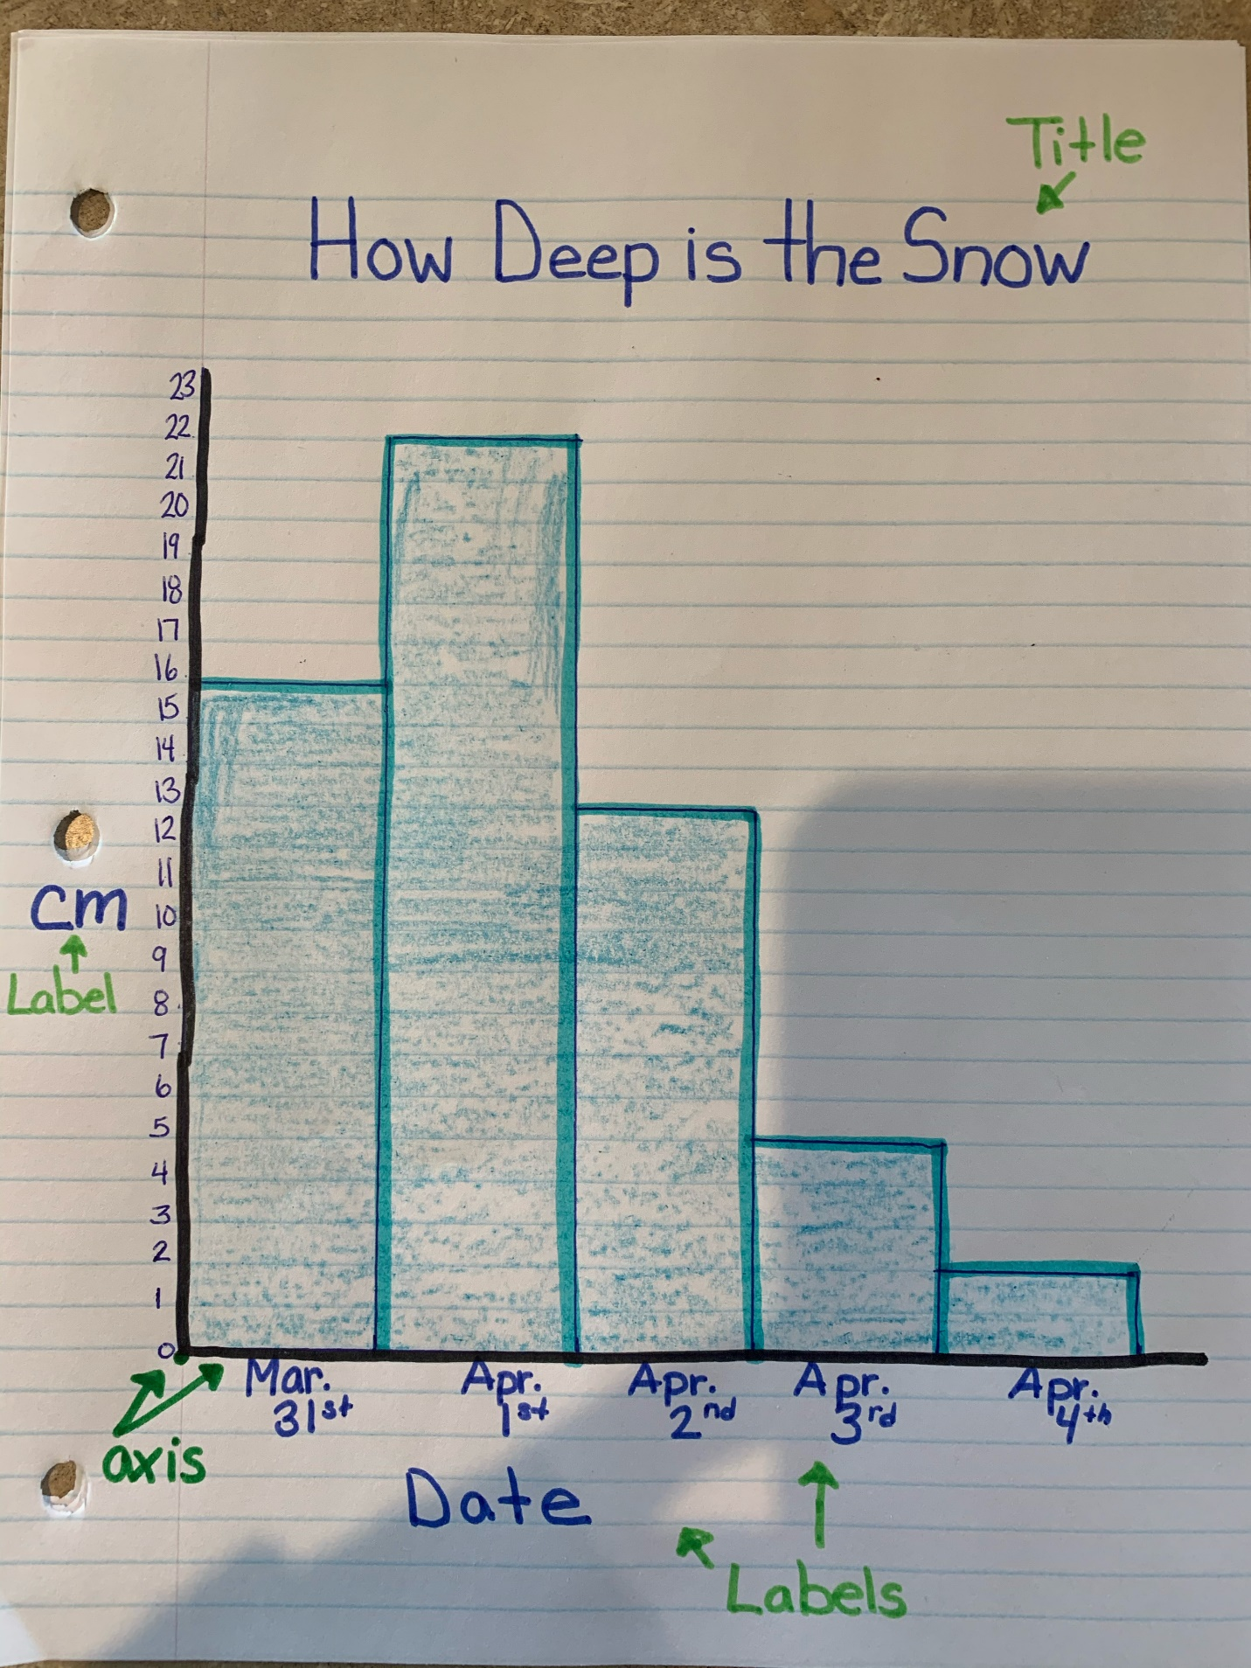
Reading: Please remember that is it important to read every day for at least 20 minutes.
Writing: Earth Day is celebrated each year on April 22nd which is this week. So for this week the suggested writing activities will be related to taking care of our Earth.
The following are suggested activities. Please try to complete at least 2 of them but you are welcome to do all if you like. Writing should be done for 20 mins. each day. You may want to write in your journal as well or use these topics in your journal.
#1. Create an Acrostic Poem using the word : EARTH DAY. We did these before using Christmas words.
E veryone should help out.
A ir pollution
R ecycle when you can.
T
H
D
A
Y

#2. Write about the different ways we can take care of our environment and why this is important.
#3. Make an Earth Day poster.
#4. Create a craft using recyclables. Write about what you created and what materials you used.
Science: Check out this website https://jr.brainpop.com/
I have set up a class account: Username: Gr3macdonald
Password: Grade3
I’d like you to click on the SCIENCE videos and choose CONSERVATION. Here are some videos related to Earth Day. Watch them, complete the Quiz, and/or check out other features of this site.

Remember to have fun with this new way of learning and do what you can. You can always reach me by email if you have any questions: kelly.macdonald2@nbed.nb.ca
Take care and have an awesome week!

