Math: continue working on the math site: iknowit.com (found in the web link section).

Here are some activities from the Math Leads at ASD-N.

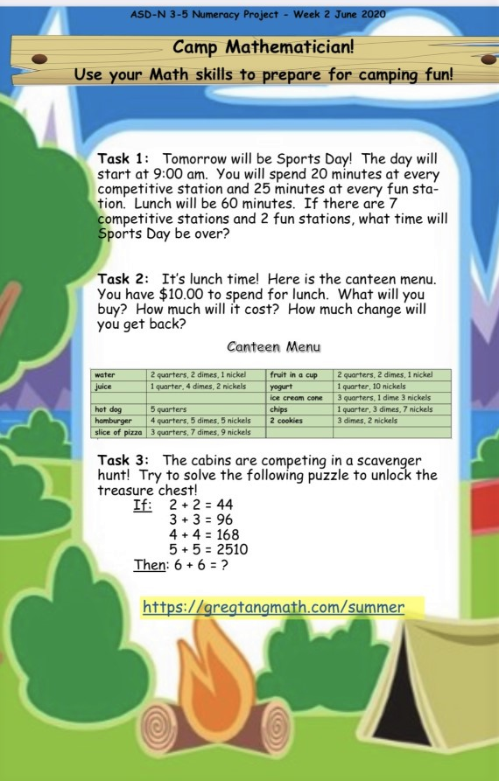

https://gregtangmath.com/summer

Literacy:
Reading: Please remember that is it important to read every day for at least 20 minutes. This would be a good idea to continue doing throughout the summer.

Writing: We began our Home Learning with a letter and I think it would be nice to end it the same way.
I would love to receive another letter from you!!! Let me know what you have been up to. Do you have any plans for the summer? I would really like to know. You can type it to me via email or send a photo! I can’t wait to read them!!!

Science: www.brainpopjr.com
Gr3macdonald
Password: Grade3

A Big Happy Birthday goes out to Dom and Teaghan who both celebrate their birthday on June 15th!!

Also celebrating a birthday this summer are Ethan and Megan in July and Jesse in August. Hope you all have a great day!
You can always reach me by email if you have any questions: kelly.macdonald2@nbed.nb.ca
Take care and have an awesome week and a fantastic summer!

