La semaine du 11-15 mai
FRANÇAIS

Le son de la semaine : ille (ex : fille, croustilles, billes, chenille, papillon, Guillaume...) See YouTube video below https://www.youtube.com/watch?v=sz1JkS0Ve6M ** See the pictures of the Guillaume Gorille sound card on the FB group
Les mots de la semaine : à propos, avait, avais, vers, vouloir, monte See the Powerpoint – Revisit DAILY
lundi | mardi | mercredi | jeudi | vendredi
This week, we are going to explore the life cycle of a plant.  Watch this short clip on the life cycle of a plant:  https://www.youtube.com/watch?v=Zi0veiCpKXI  PowerPoint:  View the PowerPoint on the Teacher page for more information and the vocabulary on the life cycle of the plant. | A book has been assigned on:  https://www.kidsa-z.com/main/Login  (La croissance d’une graine)  *** We realize this book may be difficult for your child to read independently. We posted a video on the Facebook group of the book being read aloud for your child to follow. ***  Find the Grade 2 sight words in your book (La croissance d’une graine). Write them down and read them out loud to a family member. | Draw all 6 stages on a sheet of paper and write down the names of each stage. En français!  The 6 stages / Les 6 étapes :  - Plante la graine.  - La graine germe.  - Les racines poussent.  - La tige pousse.  - Les feuilles poussent.  - La plante est adulte. | Writing:  Go outside and find a plant.  Describe it.  Location, size, colors, …  _________  Ex:  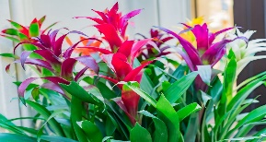  La plante est derrière ma maison. Elle est grande et elle a du violet, du rose et du jaune. Elle a aussi une tige verte et des feuilles. |  | Arts:  Make a flower craft of your choice and share it with your friends on the Facebook Group. Be creative and have fun.  Examples :  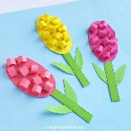  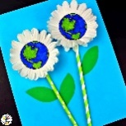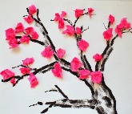  Bonne fin de semaines les amis!
La semaine du 11-15 mai
MATHS
** Your child can play on SplashMath or Prodigy in addition to the daily activities.
lundi | mardi | mercredi | jeudi | vendredi
Activity today :  Growing Patterns/ Prolonger les régularités croissantes :  Watch this video for an example of the concept this week.  https://www.youtube.com/watch?v=aRdqLeZck7g  Copy the patterns:  https://ca.ixl.com/math/grade-2/growing-patterns  What do you notice? | Activity today:  Prolonge les régularités croissantes :  Worksheet found on the teacher page. | Activity today:  Prolonge les régularités croissantes :  Complete the growing patterns:  https://ca.ixl.com/math/grade-2/find-the-next-row-in-a-growing-pattern | Activity today:  Make your own growing pattern using things found inside or outside your house.  ** See Facebook group for pictures of our examples. **  Take a pic and post it on the Facebook group to show your friends. | Activity today:  Go on SplashMath or Prodigy  OR  Play a Math card game/Board game with a family member.

