Math: continue working on the math site: iknowit.com (found in the web link section).

New Concepts for this week: Multiplication and Symmetry

Videos: On symmetry https://www.youtube.com/watch?v=YFzktJNmnPU
https://www.youtube.com/watch?v=Kah5w06eyCo

Tasks:
- Open Document: Worksheet to review showing multiplication using pictures, repeated addition sentence, multiplying sentence, and an array using dice.
- Here are some activities from the Math Leads at ASD-N
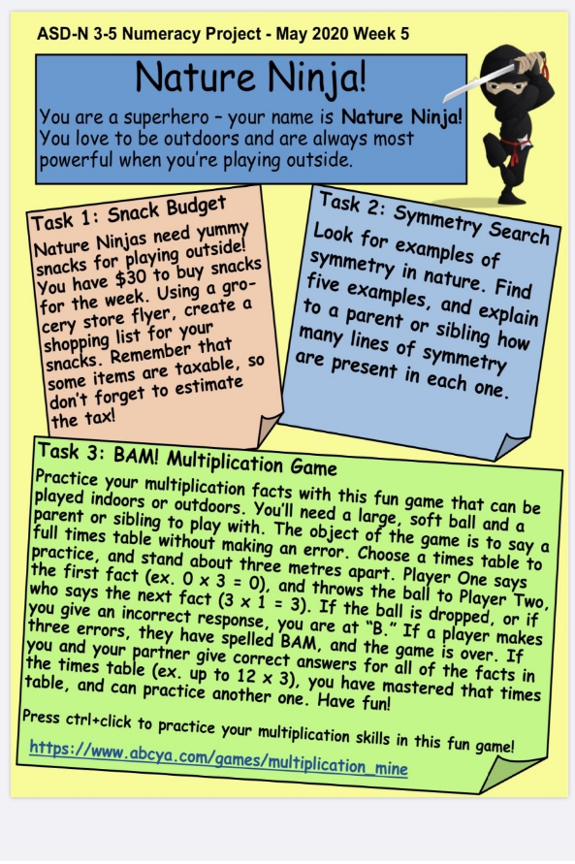

- Website: www.mathplayground.com
Has great multiplication games to practice facts.

Grade 3 curriculum only asks for students to know up the 5x tables but feel free to practice all if you like.
Literacy:
Reading: Please remember that is it important to read every day for at least 20 minutes.
While reading try to pick out some interesting vocabulary words that the author has used. Make a list.

Writing: The following are suggested activities. Writing should be done for 20 mins. each day. You may want to write in your journal as well or use these topics in your journal.
- Write a Procedure (How to… story) on: How to wash your hands.
- Write a Procedure on: How to make your favorite sandwich.
Cursive Writing: I have sent home your cursive writing duotang (purple). Continue learning how to make each letter of the alphabet.

Science: www.brainpopjr.com
Gr3macdonald
Password: Grade3
Check out the Health Section. Choose “All movies”, and Select “Washing Hands”. Remember you can watch any of the videos on all the topics at any time. Enjoy!
Remember to have fun with this new way of learning and do what you can. You can always reach me by email if you have any questions: kelly.macdonald2@nbed.nb.ca
Take care and have an awesome week!

