Math: continue working on the math site: iknowit.com (found in the web link section). I see that the students that are trying it, are doing well. I have added some new assignments for you to try.

New Concepts for this week: Multiplication and Symmetry

Videos: On symmetry https://www.youtube.com/watch?v=YFzktJNmnPU
https://www.youtube.com/watch?v=Kah5w06eyCo

Tasks:
- Open Document: Worksheet to review showing multiplication using pictures, repeated addition sentence, multiplying sentence, and an array . I have also included some counting money sheets. (Don’t forget that you can check your work afterward because I am also attaching the answer sheets.)
- This week, continue to practice the 0,1,2,4,5 times tables and then practice the 3 times table. The only hint is to simply count by 3’s as many times as you are multiplying by. Ex: 3x3, start and count 3,6,9 (3 times). The answer is 3x3=9; 3x4, Think, 3,6,9,12, so 3x4=12. Have your parents give you 10 questions each Friday to check your progress of the times tables that you have learned.
- Here are some activities from the Math Leads at ASD-N (in case you didn’t try it last week) I will post this weeks activities when I get them.
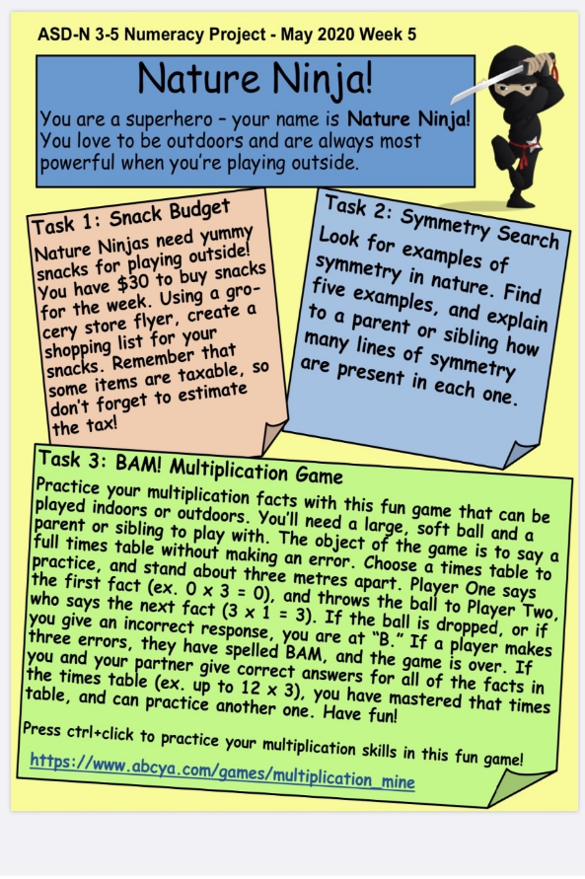

- Website: www.mathplayground.com
Has great multiplication games to practice facts.

Grade 3 curriculum only asks for students to know up to the 5x tables but feel free to practice all if you like.
Literacy:
Reading: Please remember that is it important to read every day for at least 20 minutes. You can read anything! (Newspapers, recipes,comics, magazines, etc)
While reading try to pick out some interesting vocabulary words that the author has used. Make a list. LOOK FOR ADJECTIVES AND STRONG VERBS!

Writing: The following are suggested activities. Writing should be done for 20 mins. each day. You may want to write in your journal as well or use these topics in your journal.
- Write a Procedure (How to… story) on: How to wash your hands.
- Write a Procedure on: How to make your favorite sandwich.
Watch these links to help:
https://www.youtube.com/watch?v=xvGeBcfysDo
https://wtyw.weebly.com/procedural-writing.html

Cursive Writing: I have sent home your cursive writing notebook.
Continue learning how to make each letter of the alphabet. Ask an adult to help.

Science: www.brainpopjr.com
nancy.hambrook
Password: Grade3
Check out the Health Section. Choose “All movies”, and Select “Washing Hands”. Remember you can watch any of the videos on all the topics at any time. Enjoy!
Also, check out Doug at this link:
https://mysteryscience.com/mini-lessons/unicorns?loc=mini-lesson-button#slide-id-8702
Remember to have fun with this new way of learning and do what you can. You can always reach me by email if you have any questions: nancy.hambrook@nbed.nb.ca
Take care and have an awesome week! Check out Mr. Noel’s teacher page. The Virtual Olympics start today!

