Hello,
Today, Wednesday November 3, students may do the following
Numeracy (60 min)
- Zorbits – play for 20-30 min: https://play.zorbitsmath.com/
- Count by 10 to 100. Try starting at different numbers (ex: 11, 21, 31, 41, 51, 61, 71, 81 ,91).
- Count backwards from 100 by 10 – use the gameboard and the dry erase marker in your package
- Count by 2 to 100 – use the gameboard and the dry erase marker in your package
- Try counting backwards by 1 from 50. For a challenge start at 100!
- Something different to do today…. Don’t forget I would love to see some pictures
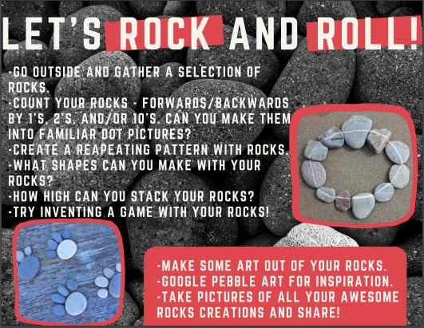
Literacy (60 min)
- Read the books in ‘Je lis je lis’. You can record yourself reading and I will listen to it Please don’t forget to click the green button at the end of the book, so I know you read it at least once. Students should read the same books over a few days to help with fluency. I will be changing the books every few days
- Sound ‘j’ – watch the short video. Listen and sing the ‘comptine’ for the sound – j (Ginette Girafe). The letter ‘j’ always makes the ‘j’ sound, and the letter ‘g’ makes the ‘j’ sound when it is in front of the letters ‘e’, ‘i’, and ‘y’. Then read the ‘comptine’ and find words with the sound.
- Listen to the words of the week (Semaine 8): parfois, journée, hier, jamais, demain, le, on, sur, les, c’est. Then try reading the words without the sound.
- Listen to the Power Point presentation with the other words of the week in sentences. Try making your own sentences
- Write the words of the week like a robot. See my example at the bottom.
- Use a game board and write words on it. Practice reading the words. See my picture at the bottom - aime, manger, pendant, que, veut, quoi, doit, autre, prend, vient, ami, bon, ils, fait, veux, ses, peux, comment, prendre, ont, amie, suis, elles, fait, donne, voit, peut, porte, chaque, dort, être, eau, est, gros, donner, vois, quel, court, viens, entre, mange, et, aller, trop, quand, lui, quelle, faire, vais, jouer, où, père, mère, merci, bonbon, la, mes, à, avec, tu, rester, jour, soir, matin, midi, je, un, une, des, mon
- Listen to the PowerPoint presentation with the message of the day for the new French sentence. Then try writing your own Don’t forget about the website wordreference.com to help you.
  - Pour être en bonne santé je mange ______ et _______.
- YouTube videos that go with our theme:
https://www.youtube.com/watch?v=FE07LMSRiXk
https://www.youtube.com/watch?v=4TmHV4fJf8U
10. Extra - Listen to French stories on Tumble Books:
https://www.tumblebooks.com/
  - Username: nblib password: nbschools
  - Some may be a bit difficult but listening to French is important
Please take some time to get outside and play
https://www.wordreference.com/ is a great tool to use for translating words from English to French and vice versa. Great for simple writing activities we will be doing this week.

You may send photos that I can share with our class in the Teams page reba.carroll@nbed.nb.ca

Mme Carroll

