Math: We always begin our day with Math.

- Here is a Mystery Number Warm-Up problem:
The number is less than 195 but greater than 185.
It has 8 more tens than ones.

- Worksheet in home learning packet: Find numbers in the flyers and cut them out and make the 3-digit numbers to match the clues. If you don’t have scissors or glue…just print numbers to match the clues.
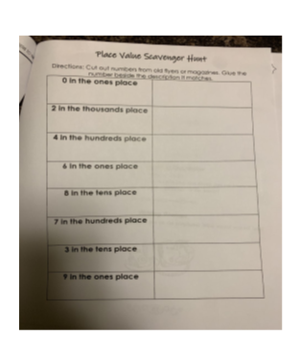

- Log onto Splash Learn and work on some of the assignments.
www.Splashlearn.com Username: SNTXCE Password: memo34

Literacy:
Word Work: Here are our spelling words/pattern that we are looking at this week:
Feet asleep teeth queen street weekend screech needle every about ago first

*Try to make a list of other words that also have the “ee” pattern. How other words can you think of?
* There is a worksheet in the packet that shows that “ea” can also make the long e sound. You can work on this sheet as well.
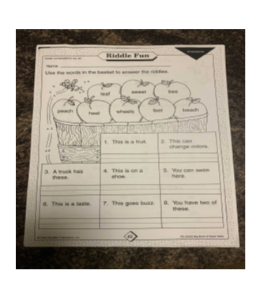

Reading: Remember it is very important to read each day for 15 mins. You can read aloud to someone or to yourself if it’s a chapter book.
After reading answer the following questions about the book or chapter.
- What is the setting of the story?
- Who are the characters in the book?
- What was the story about? Print 1-2 sentences about what happened in the story.

Cross-Curricular: In Science we will begin by learning how to make observations and diagrams.

Watch this video on how to use your 5 senses to make observations: https://youtu.be/RvmF9OWrXWA

If you can…go outside and find a leaf or a rock. Then record your observations: What does it look like? Size/shape/color/ How does it feel? Do you know what kind of tree it came from? Then draw a diagram (picture) of your leaf/rock and color it.

***Don’t forget to keep all work that is completed so that you can bring it back to school with you when we return.

Recommended time frames for Home Learning:
30 mins of physical activity
90 mins of Literacy and Math
Remember to have fun with this new way of learning and do what you can.
You can always reach me by email if you have any questions: kelly.macdonald2@nbed.nb.ca

