Math: We always begin our day with Math.

- Here is a Mystery Number Warm-Up problem:

I am a 2-digit number.
I am an odd number.
The sum of my digits is 8.
Both the digits are odd.
I am less than 30.

- Log onto Splash Learn and work on some of the assignments.
www.Splashlearn.com Username: SNTXCE Password: memo34

- The chart shows how far some students travelled on their holidays.
Name Distance Travelled
David 225 km
Serena 250 km
Mabel 590 km
Enrique 500 km

Who travelled the greatest distance? ____________________________________
Who travelled the least distance? _______________________________________
Who travelled further than David but not as far as Enrique? _________________

- Using the digits 4 9 and 6 . Make as many 3-digit numbers as you can.

Literacy:
Word Work: In the learning packet there are sheets about verbs. Verbs are action words used in a sentence. They tell what the noun (person, place or thing) are doing. Complete the sheet.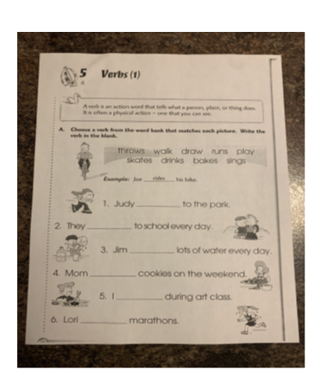

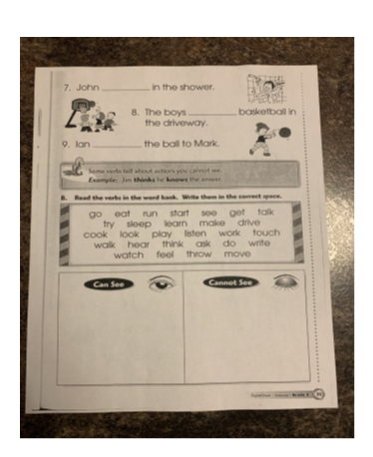
Reading: Remember it is very important to read each day for 15 mins. You can read aloud to someone or to yourself if it’s a chapter book.While reading: make predictions as to what you think might happened next.

Writing: Write another story about something you did. It could be something you did on the weekend, yesterday, even last summer. Remember to use capital letters and punctuation marks.

Cross-Curricular: **** same activity as yesterday***
*** if you didn’t get a chance to do the activity below you can try it today. If you did it then today go back outside, find a spot on the ground (about the size of a hoola hoop) and make observations as to what you can see. Is there soil? Grass? Living things? Rocks?

In Science we will begin by learning how to make observations and diagrams.

Watch this video on how to use your 5 senses to make observations: https://youtu.be/RvmF9OWrXWA

If you can…go outside and find a leaf or a rock. Then record your observations: What does it look like? Size/shape/color/ How does it feel? Do you know what kind of tree it came from? Then draw a diagram (picture) of your leaf/rock and color it.

***Don’t forget to keep all work that is completed so that you can bring it back to school with you when we return.

Recommended time frames for Home Learning:
30 mins of physical activity
90 mins of Literacy and Math
Remember to have fun with this new way of learning and do what you can.
You can always reach me by email if you have any questions: kelly.macdonald2@nbed.nb.ca

