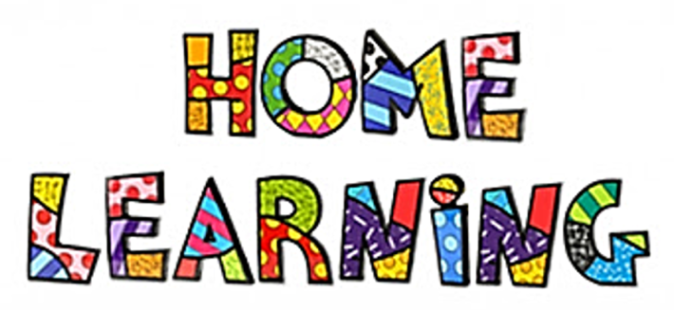

I hope you all had a great week so far! You can continue to work with your home learning package and if you are looking for more to do, I will leave a few options below! This document can be used for the rest of the week!

Math & Language Arts
ABCYa games: You may click on Grade 4 and you can work on any literacy or math-based games! I can’t wait to hear about which ones you played and how fun they were. https://www.abcya.com/grades/4

Math
Splashlearn: Log in information was sent home previously, email me if you need a reminder with what it is. https://www.splashlearn.com/signin

Brainpopjr Video: Time https://jr.brainpop.com/math/time/timetotheminute/

Times Tables: Review your 0 , 1 , and 2 times tables to 10.
0: https://www.youtube.com/watch?v=djqQ_7vke2Q
1: https://www.youtube.com/watch?v=ufc38buf64E
2: https://www.youtube.com/watch?v=6RHvIUry_uc

Toothy
A separate Document will be posted with an interactive game for students to play on an iPad/Tablet, Phone, or computer.
Language Arts
Reading/ Listening to Reading:
- Reading Comprehension Booklets: you can print or use a piece of loose leaf to work on. (separate part of teacher page under documents)
- Read for 30 minutes (library book or any you have around the house)
- Watch a story (storyline Online): https://storylineonline.net/

Word Work: Review Homophones: Work on the differences between your and you’re & there, their, and they’re. Write out a few sentences using each. In the Documents I will add a few work sheets you can do!

Writing:
Use your imagination and write a fictional story about a haunted house. Plan out what you will write first. Think of an AMAZING introduction, middle and ending! Don't forget to use your paragraph starters (First, Then, Next, Finally). Once you're finished you can draw a picture to go with your story!

Cross-Curricular (Health, Science, Social Studies)
Phys. Ed:
Check out Mr. Williston & Ms. McFarlane’s Teacher Pages for some fun activities to get you moving!

BrainBreak (Go Noodle) or Go Noodle on YouTube!
Health/Science
Brainpopjr Videos/ Quizzes
Mindfullness (FREE)
https://jr.brainpop.com/health/feelings/mindfulness/
Empathy
https://jr.brainpop.com/health/feelings/empathy/
Wetlands
https://jr.brainpop.com/science/habitats/freshwaterhabitats/

Art:
Art Hub for Kids (Halloween or Fall Playlist) Choose a video and bring me in your artwork on Monday!
https://www.youtube.com/playlist?list=PLnoO3k54vcBTlrs0oPeaPPk4tvbP7

Social Studies/ Social Studies:
Explore something new today! Either explore outside or try something new, even exploring a new idea or understanding how something works!
Think about an animal that might live in Canada. Do some research on what it needs to survive and what its habitat looks like. You can even create a habitat with materials from home!
Look outside for rocks and describe them and what they look and feel like. Draw a picture to go with that!

