Mme Russell | Home Learning- Wednesday, January 12, 2022
 | Warm Up: Using the calendar template in the home learning packet, write the date, the weather and the season with a white board marker. Don’t forget to say it orally
Literacy  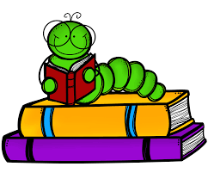 | Words: écouter, neige, personne, plaisir, froid, très, jusqu’à, besoin, enfant, lorsque  Work Work: Les mots arc-en-ciel (Rainbow words)  On a blank piece of paper, write your words using rainbow colors. You can use markers, crayons, pencil crayons, paint. You can be as creative as you want! Don’t forget to read the words after you write them!!  I also posted a PowerPoint on Teams of 5 of the words of the week being used in a sentence. You can listen to the PowerPoint and repeat the sentences out loud.  Sound: Eugénie Émeu- “eu”  Eugénie Emeu - YouTube (song)  Eugénie Émeu - YouTube (words)  Reading: Je lis, je lis, littératie ! ONLINE (rkpublishing.com)  Three books have been assigned to each child on the Je lis! Website. Each book should be read a few times throughout the week. Please work on things like fluency, expression and volume. If you feel you are ready, you can record yourself reading and I will listen to it
Math  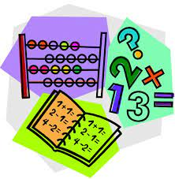 | - Play Zorbit Math for 20 minutes.  - Practice counting backwards by ones starting at different numbers. Please use the deck of cards in your home packet. Remove all the 10s and the face cards. Flip two cards over to make a double-digit number. Starting at that number, say the five numbers that follow. After you have done this a few times, try counting by 10s.  - In your home learning packet, please find the worksheet in the math section titled “Casse-têtes de nombres”. Please fill in the smaller pieces of the hundreds chart. You can use your hundreds chart from yesterday to help you.  - Give these a try:  IXL | Counting patterns - up to 100 | Grade 2 math  IXL | Skip-count by tens | Grade 2 math  ** These websites are in English but you can do your counting in French
Exploration,  Art,  You and Your World  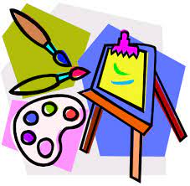 | In your home learning packet, there is a small booklet titled “Le nouvel an”. On one page they will have to draw a picture of themselves at the beginning of 2022. The next page they will pick 3 emojis that represented their 2021. Finally, they will have to write 3 resolutions. These don’t have to be detailed. They can write one word on the line. They could even use the 3 things that they used on the activity from yesterday  Don’t forget to take the time for fresh air and physical activity. You can also check Mr.Williston’s Phys.ed page and Mrs. Comeau’s music page.  If you have any questions/comments/concerns, please send me an email at sara.russell@nbed.nb.ca.  Have a great day!!  **Please remember to keep all completed work for when we return to school.

**If you want to share pictures of your home learning, you are welcome to post on the Teams page. You can also send them to me, and I can post on the teacher page and the Teams page

