Mme Russell | Home Learning- Thursday, January 13, 2022
 | Warm Up: Using the calendar template in the home learning packet, write the date, the weather and the season with a white board marker. Don’t forget to say it orally
Literacy  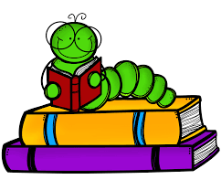 | Words: écouter, neige, personne, plaisir, froid, très, jusqu’à, besoin, enfant, lorsque  Work Work: Building words  Today we are going to build the words using lego, playdoh, blocks, letter tiles, magnetic letters, or anything else you have in your house. You can post a picture on the Teams page when they are done  I also posted a PowerPoint on Teams of the last 5 words of the week being used in a sentence. You can listen to the PowerPoint and repeat the sentences out loud.  Sound: Eugénie Émeu- “eu”  Eugénie Emeu - YouTube (song)  Eugénie Émeu - YouTube (words)  After listening to both videos, can you make a list of words that have the sound “eu” in it? Use your “whiteboard” in you learning packet.  Reading: Je lis, je lis, littératie ! ONLINE (rkpublishing.com)  Three books have been assigned to each child on the Je lis! Website. Each book should be read a few times throughout the week. Please work on things like fluency, expression and volume. If you feel you are ready, you can record yourself reading and I will listen to it
Math  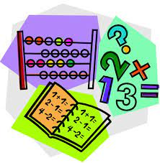 | - Play Zorbit Math for 20 minutes.  - Today we will be working on representing numbers. Please take the number 53 and represent it as many ways as possible. Some suggestions are base ten blocks, ten frames, tally marks, money, dice, words, equations, odd/even etc. Please use the whiteboard in your learning packets. I will post an example using 78 on the Teams page.  - Play a game of addition war with the deck of cards to practice addition facts to 20. All face cards are worth 10 and the A’s are worth 1. Each person flips 2 cards and adds them together. Whoever has the bigger number wins the cards. If the total is the same, then flip 2 more. The higher number always keeps the cards. Whoever wins all the cards or who has the most at the end, wins the game.
Exploration,  Art,  You and Your World  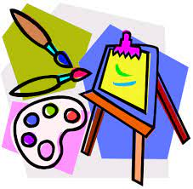 | Art:  Comment dessiner un bonhomme de neige- étape par étape  Comment dessiner un BONHOMME DE NEIGE étape par étape | Dessin Pour Enfant - YouTube  Please watch this directed drawing video about how to draw a snowman. You will need a piece of paper, a pencil and something to color with. They use a marker in the video. I would suggest using a pencil and then outlining it in black when you are finished. I would love to see pictures of the finished product  Don’t forget to take the time for fresh air and physical activity. You can also check Mr.Williston’s Phys.ed page and Mrs. Comeau’s music page.  If you have any questions/comments/concerns, please send me an email at sara.russell@nbed.nb.ca.  Have a great day!!  **Please remember to keep all completed work for when we return to school.

