Mme Russell | Home Learning- Friday January 14th, 2022
 | Warm Up: Using the calendar template in the home learning packet, write the date, the weather and the season with a white board marker. Don’t forget to say it orally
Literacy  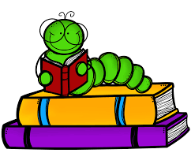 | Words: écouter, neige, personne, plaisir, froid, très, jusqu’à, besoin, enfant, lorsque  Work Work: Writing sentences  Can you write sentences with the words of the week? Pick two words and write a sentence with each. Make sure you use a capital letter at the beginning and a period at the end.  Sound: Eugénie Émeu- “eu”  Eugénie Emeu - YouTube  Chanson du son eu - YouTube  [eu] [oeu] Eugénie Émeu - YouTube  Reading: Je lis, je lis, littératie ! ONLINE (rkpublishing.com)  Three books have been assigned to each child on the Je lis! Website. Each book should be read a few times throughout the week. Please work on things like fluency, expression and volume. If you feel you are ready, you can record yourself reading and I will listen to it
Math  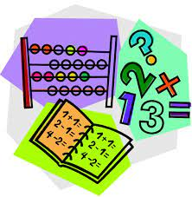 | - Play Zorbit Math for 20 minutes.  - Today we will be working on comparing and ordering numbers. Using the deck of cards, remove the 10s and the face cards. Flip 10 cards to make five, 2-digit numbers. Write these two-digit numbers in order from smallest to biggest on your whiteboard (l’ordre croissant). You can repeat this 3 times.  - In your home learning packet find the worksheet that has the word “ordonner” in the top left corner. Order the numbers from smallest to biggest.  - Give these a try:  Numerical Order | Putting Numbers in Order • ABCya!  Caterpillar Ordering - An Ordering and Sequencing Game (topmarks.co.uk) (Click ordering and choose numbers 1-100)
Exploration,  Art,  You and Your World  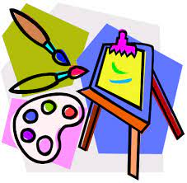 | Some videos about fruits and vegetables:  apprendre les fruits et les légumes en français - YouTube  J'aime les fruits - alain le lait (I like fruits) - YouTube  In your home learning packet, there is a work sheet with “les fruits” et “les legumes”. Please cut out the pictures of food at the bottom of the page. Then you will then sort the food into 2 groups: fruits and vegetables. After you are certain they are correct, you can glue and color them.  Don’t forget to take the time for fresh air and physical activity. You can also check Mr.Williston’s Phys.ed page and Mrs. Comeau’s music page.  If you have any questions/comments/concerns, please send me an email at sara.russell@nbed.nb.ca.  Have a great day!!  **Please remember to keep all completed work for when we return to school.

