Mme Russell | Home Learning- Tuesday, January 11, 2022
 | Warm Up: Using the calendar template in the home learning packet, write the date, the weather and the season with a white board marker. Don’t forget to say it orally
Literacy  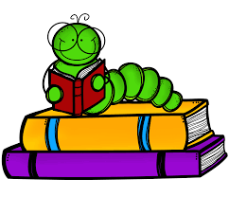 | Words: écouter, neige, personne, plaisir, froid, très, jusqu’à, besoin, enfant, lorsque (**this is a review of words that were done before Christmas)  A video of the words will be uploaded to the Microsoft Teams page. Please listen to the video 3 times. On the third time, please mute the video and try to read the words yourself.  Sound: Eugénie Émeu- “eu”  Eugénie Emeu - YouTube  Can you find the “eu’s” in the song? A copy of a poem has been uploaded to the Microsoft Teams page.  Reading: Je lis, je lis, littératie ! ONLINE (rkpublishing.com)  Three books have been assigned to each child on the Je lis! Website. Each book should be read a few times throughout the week. Please work on things like fluency, expression and volume. If you feel you are ready, you can record yourself reading and I will listen to it
Math  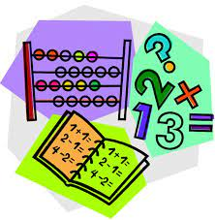 | - Play Zorbit Math for 20 minutes.  - Practice counting forward by ones starting at different numbers. Please use the deck of cards in your home packet. Remove all the 10s and the face cards. Flip two cards over to make a double-digit number. Starting at that number, say the five numbers that follow.  - In your home learning packet, please find the worksheet in the math section at the back of the duo-tang titled “Exercices avec les nombres de 0 à 100.” Please fill in the hundreds chart and answer the questions at the bottom. (Vocabulary: entre-between, avant: before, après: after.)  ** If you did not receive your home learning packet yet, please try the game below. This game is in English. Click the challenge button. You can mute the volume and say the number in French as you click on them  Number Chart Game • ABCya!
Exploration,  Art,  You and Your World  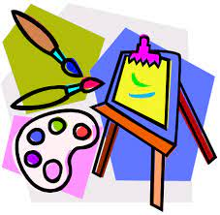 | In your home learning packet, there is a worksheet titled “Mes Résolutions”. In each section on the sheet, draw a picture of something you would like to work on or something new you would like to try this year. Once you draw a picture, try writing a word to go along with it. Some examples could be : santé (health), lecture (reading), exercices, dormir plus, nourriture, moins technologie, les sports etc.  *If you did not receive your home learning packet yet, you can do the above activity on a blank piece of paper.  Don’t forget to take the time for fresh air and physical activity. You can also check Mr.Williston’s Phys.ed page and Mrs. Comeau’s music page.  If you have any questions/comments/concerns, please send me an email at sara.russell@nbed.nb.ca.  Have a great day!!  **Please remember to keep all completed work for when we return to school.

