June Events

Who: 4-Glazier
June 3: Joseph and the Technicolor Coat
We have been invited to watch the JMH drama production of Joseph and the Technicolor Coat on June 3rd. Students are asked to bring in $2 to attend. If you are unable to send in the money, the school will cover the cost. We ask students to wear appropriate footwear as we will be walking to and from James M Hill.

June 8: Chatham Library and picnic
We will be walking to the library @ 11:00 and have a picnic lunch afterwards. Please pack a lunch, snacks, and lots of water. Your child must wear proper footwear to walk down.

June 14: The Healing Farm
The bus will be leaving the school promptly at 8:40am and returning at approximately 2:30pm. Please remember to dress according to the weather. After the farm, we will be stopping at Ritchie’s Wharf for a picnic lunch (students must bring a bagged lunch). Students will be permitted to use the Splash Pad. A change of clothes and a towel will be required.

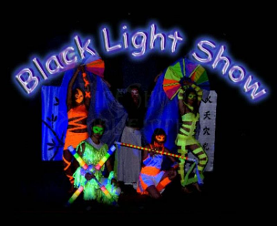
Wednesday, June 15th: Black Light Show
Students will be walking to James M. Hill to see our very own Grade 5 students perform in our famous Black Light Show!

Friday, June 17^{th:} Ducks Unlimited
Our class will be going to The Miramichi Nature Park. Please make sure your child is dressed appropriately for the weather that day (sunscreen, fly repellent, rubber boots, (no sandals), raincoat if needed, etc…). Please make sure to send the permission slip in as soon as possible.

Monday, June 20th (rain date: Wednesday, June 22nd): Track & Field Day
We will be attending the District Track and Field Meet at JMH. Please ensure your child has proper attire for this day, as well as sunscreen, lots to eat and drink.

For outdoor activities, please remember to send sunscreen, bug spray, and water.

