King Street Kindergarten
Home Learning June 8-12, 2020
Monday  June 8 | Tuesday  June 9 | Wednesday  June 10 | Thursday  June 11 | Friday  June 12
Making Memories!  It is the last week of school! Draw a picture and/or write about something you loved about kindergarten! | Get Creative!  Build something with LEGO/blocks or draw/paint a picture or create something of your own.  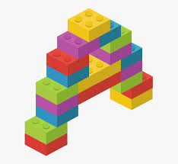 | Storytime!  Click on the link to listen to the story, The Very Hungry Caterpillar:  https://www.youtube.com/watch?v=75NQK-Sm1YY  Answer these questions about  the story:  * What did the caterpillar eat first?  * What did the caterpillar eat last?  * How long did the caterpillar stay in the cocoon?  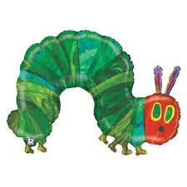  * What did the caterpillar change into?!! | Get Active!  Get outside today and have fun in the sun! | Time to Celebrate!  It is the LAST day of school! Draw a picture and/or write about something fun you want to do this summer!

