Good morning, Boys, Girls and Guardians,
Lesson Plan- Tuesday, November 3, 2021
On Monday, November 1, 2021, we began Home Learning. Posted below are recommendations as well as a visual schedule of what a day of At Home Learning can look like
30 Minutes of Physical Activity is encouraged and 45 minutes a day for Literacy and Numeracy are recommended for students in Grade 1.
9:00-9:30 | Soft Start (this is how we begin our day at school). Choose an activity  - Coloring  - Building  - A walk outside  - Help cook breakfast
9:30-9:45 | Read a book- Make it fun. Read in one of the creative/fun ways listed on one of your November Reading Bingo which has been uploaded to our teacher page.
9:45-10:00 | In your Home Learning Booklet on Page 3. Play the game” Spill a Sight Word” These games will help your child learn to read and write their sight words. Note: Your child’s sight words are in their Sight Word Duotang that was sent home in September.
10:00-10:15 | Brain Break- Go onto You tube and search “Have Fun Teaching Walking Song”
10:15-10:30 | Writing- On page 18 of your Home Learning is Writing Paper with an editing checklist. Write 2-3 sentences on the topic of “My Best Friend”.
10:30- 10:45 | Snack
10:45- 11:00 | 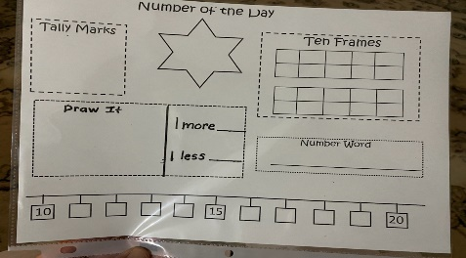  Represent the number of the day in different ways The number of the day today is 41.
11:00- 11:15 | Use a deck of cards with all face cards removed. Ace=1.  Turn over a card from each pile. Ex: I turned over a 3 and an 8, I then count forward from 3 to 8. EX#2: I turn over a 9 first and then a 5, I would have to count backwards from 9 to 5.  Have fun! Any questions just send an email for further explanation.
11:15-12:30 | Lunch
12:30-12:45 | Splashlearn and/or Squiggle Park
12:45-1:45 | Physical Education- Go outside and play
- All Students have be provided with Login information to Squiggle Park (Literacy) and Splash Learn (Numeracy).

Parents/Guardians- Please keep all student work completed during Home Learning and send it to school with your child when we return to school base learning.

