Good morning, Boys, Girls and Guardians,
Lesson Plan- Thursday, November 4, 2021
On Monday, November 1, 2021, we began Home Learning. Posted below are recommendations as well as a visual schedule of what a day of At Home Learning can look like
30 Minutes of Physical Activity is encouraged and 45 minutes a day for Literacy and Numeracy are recommended for students in Grade 1.
9:00-9:30 | Soft Start (this is how we begin our day at school). Choose an activity  - Coloring  - Building  - A walk outside  - Help cook breakfast
9:30-9:45 | Read a book- Make it fun. Read in one of the creative/fun ways listed on one of your November Reading Bingo which has been uploaded to our teacher page.
9:45-10:00 | Go on a walk outdoors and collect sticks of different lengths. Choose 3 sight words and/or 3 number words and build these words using the sticks you collected. Take a picture of your creation and we will post it on our Teacher Page. Note: Your child’s sight words are in their Sight Word Duotang that was sent home in September.
10:00-10:15 | Brain Break- Go onto You tube and search Count on Me by Bruno Mars. Sit back, relax and listen to the lyrics.  “Always be Kind, we are all here to support each other”
10:15-10:30 | https://www.youtube.com/watch?v=zMMRiGX4Us8.  Lisen to the story “Hibernation Station” and respond to the questions. Write your responses.  - What does hibernation mean?  - What did the chipmunks do in the story?
10:30- 10:45 | Snack
10:45- 11:00 | 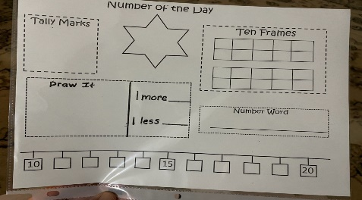  Represent the number of the day in different ways The number of the day today is 42.
11:00- 11:15 | Login to Zorbit and work on the assigned Pattern activities – 15 minutes
11:15-12:30 | Lunch
12:30-12:45 | Practice counting from 0-20 forwards and backwards beginning at various starting points. Ex:4-12, 16-10.
12:45-1:45 | Physical Education- Go outside and play
- All Students have be provided with Login information to Squiggle Park (Literacy) and Splash Learn and Zorbit(Numeracy).

Parents/Guardians- Please keep all student work completed during Home Learning and send it to school with your child when we return to school base learning.

