Good morning, Boys, Girls and Guardians,
Lesson Plan- Thursday, November 5, 2021
On Monday, November 1, 2021, we began Home Learning. Posted below are recommendations as well as a visual schedule of what a day of At Home Learning can look like
30 Minutes of Physical Activity is encouraged and 45 minutes a day for Literacy and Numeracy are recommended for students in Grade 1.
9:00-9:30 | Soft Start (this is how we begin our day at school). Choose an activity  - Coloring  - Building  - A walk outside  - Help cook breakfast
9:30-9:45 | Read a book- Make it fun. Read in one of the creative/fun ways listed on one of your November Reading Bingo which has been uploaded to our teacher page.
9:45-10:00 | Choose four sight words that you have the most difficultly recognizing and play Sight Word Tic Tac Toe with a family member using those words.  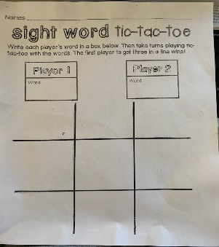
10:00-10:15 | https://www.youtube.com/watch?v=ZGiY-h3xhaw  Shape up Vowels Brain Break
10:15-10:30 | Read, fix and re-write the following sentences;  - I lik to help mi mom wash teh dishes  - can u count to for
10:30- 10:45 | Snack
10:45- 11:00 | 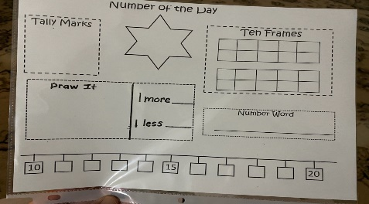  Represent the number of the day in different ways The number of the day today is 42.
11:00- 11:15 | Count around the House  -Find the objects around your house and count how many there are. Then, put the numbers in order from least to greatest.  Couches- ______  Lamps- _______  Beds- ________  Mirrors_______  Sinks ________
11:15-12:30 | Lunch
12:30-12:45 | Practice counting from 0-20 forwards and backwards beginning at various starting points. Ex:4-12, 16-10.
12:45-1:45 | Physical Education- See Ms. McFarlane’s Teacher Page for PE activities.
- All Students have be provided with Login information to Squiggle Park (Literacy) and Splash Learn and Zorbit(Numeracy).

Parents/Guardians- Please keep all student work completed during Home Learning and send it to school with your child when we return to school base learning.

