Good morning, Boys, Girls and Guardians,
Lesson Plan- Monday, November 8, 2021
On Monday, November 1, 2021, we began Home Learning. Posted below are recommendations as well as a visual schedule of what a day of At Home Learning can look like.
30 minutes of Physical Activity is encouraged and 45 minutes a day for Literacy and Numeracy are recommended for students in Grade 1.
9:00-9:30 | Soft Start (this is how we begin our day at school). Choose an activity  - Coloring  - Building  - A walk outside  - Help cook breakfast
9:30-9:45 | Read a book- Make it fun. Read in one of the creative/fun ways listed on one of your November Reading Bingo which has been uploaded to our teacher page.
9:45-10:00 | You and Your World/Literacy- This week we will be learning about Remembrance Day. Read “About Remembrance Day” on the sheet below. Chat with your children about the dashed words on the left side of the sheet and together, match them to the meaning on the right.  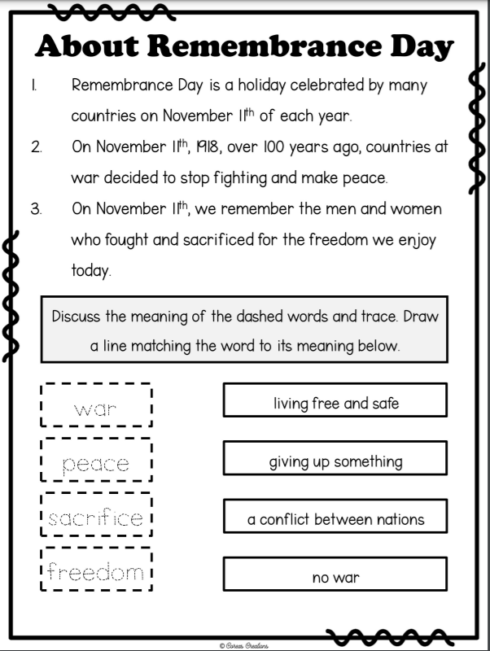  Watch the video – The Poppy Story. This is a great video that tells the story of how we and why we wear poppies for Remembrance Day.  https://www.youtube.com/watch?v=K8Jv0T9eFUY
10:00-10:15 | Brain Break  Cat Party Koo Kangaroo-  https://www.youtube.com/watch?v=LbRQLctZXa0  Workout & Count | Skip Count by 2's, 5's and 10's | Count Backwards | Jack Hartmann  https://www.youtube.com/watch?v=q_yUC1NCFkE
10:15-10:30 | Writing  Read, fix and re-write the following sentences:  - I lik to help mi mom wash teh dishes  - can u count to for
10:30- 10:45 | Snack
10:45- 11:00 | 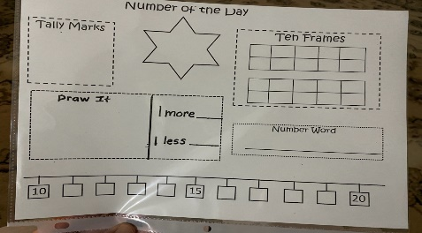  Math  Represent the number of the day in different ways. The number of the day today is 43.
11:00- 11:15 | Math  Practice counting from  0 to 20  20 to 0  4 to 15  17 to 3  Practice Skip Counting  By 2’s starting at 0 to 20  By 5’s from 0 to 20 (challenge yourself to go to 50!)  By 10’s from 0 to 50 (challenge yourself to go to 100!)
11:15-12:30 | Lunch
12:30-12:45 | Write the missing numbers on the following number lines on a separate sheet of paper. Use the number line provided to help you  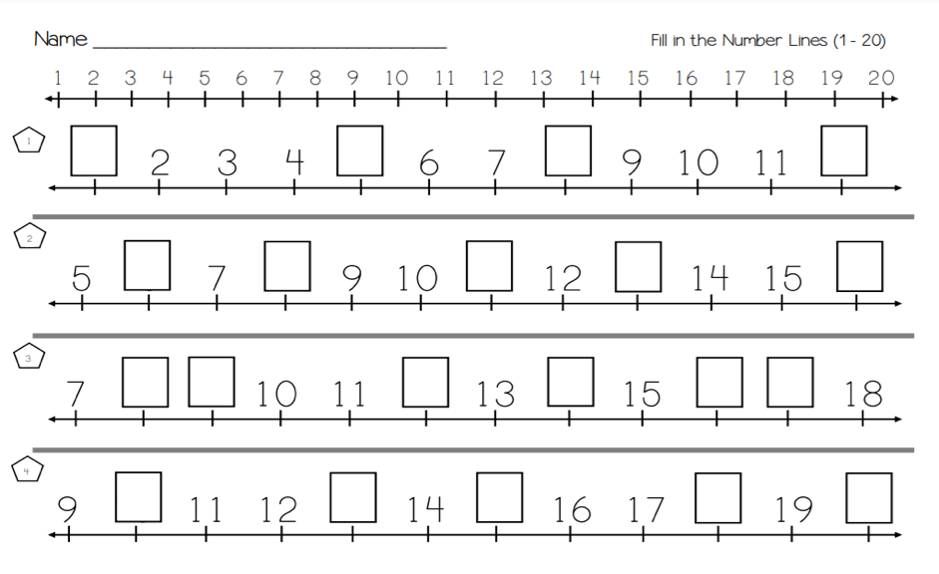
12:45-1:45 | Physical Education- See Ms. McFarlane’s Teacher Page for PE activities.  Music- See Mrs. Comeau’s Teacher Page for Music activities.
- All students have been provided with login information for Squiggle Park (Literacy), Splash Learn and Zorbit (Numeracy).
Parents/Guardians- Please keep all student work completed during Home Learning and send it to school with your child when we return to school base learning.

