Good morning, Grade One Families!
Here is the Lesson Plan- Friday, November 12, 2021

Soft Start (this is how we begin our day at school). Choose an activity
- Coloring
- Building
- A walk outside
- Help cook breakfast

Read one of the books selected for you in Epic books. Try the little quiz at the end if there is one. Not all of the books come with each book.

Sight Word Challenge: Set the timer for 2 min. See how many sight words you can print correctly on a piece of paper.

Review your sight words – Start with Level A words see how many words you can say correctly. Once you get 5 incorrect, stop. Set those 5 words aside as the ones you should work on next week.

Play a Math Game with someone!! There are lots to pick from in your green duo tang or from the learning pack. Have a game of Crazy 8's or 7 up! Crazy 8’s will help you with skip counting by five’s and 10’s! 7 up will help you with counting in order and number recognition! Or even better, change 7 up to 10 up!
Login to Zorbits Math and work on completing your assignments

Login to Squiggle Park and work on the activities for 15 minutes
Lunch

Art
Let’s Learn about the Famous Artist Pablo Picasso and Cubism! Cubism is a style of art which tries to show all of the possible viewpoints of a person or an object all at once. It is called Cubism because the items represented in the artworks look like they are made out of cubes and other shapes.

Color a cubist autumn tree
Play with color in this whimsical project. The tree trunk is made of a piece of black construction paper, but if you don’t have any on hand, simply color it black instead. Click on the link for the tutorial!

http://krokotak.com/2017/09/cubism-autumn/

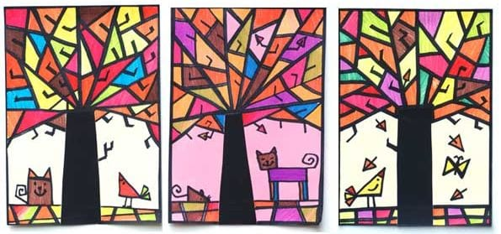

OR try this art idea only paper and the colouring tool of your choice is required! !

https://www.youtube.com/watch?v=dMDdF9XpHjs

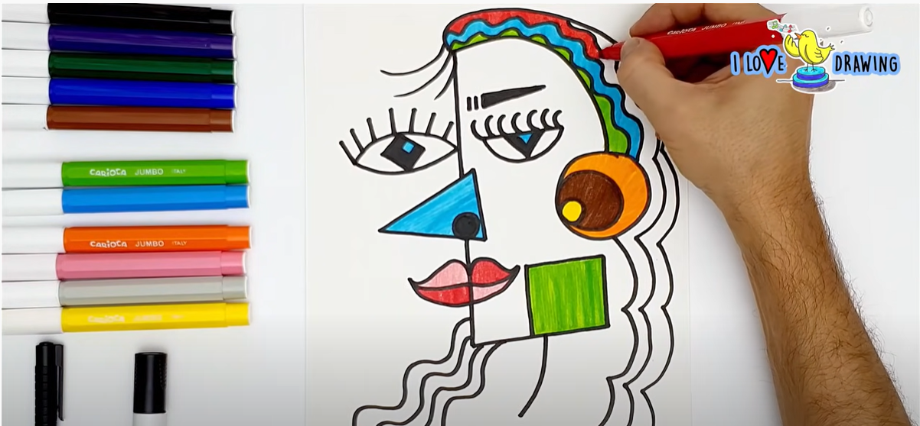

Physical Education- See Mrs. McFarlane’s Teacher Page for PE activities.
Music- See Mrs. Comeau’s Teacher Page for Music activities

Did you know Mrs. Comeau’s famous black light show has an act that is inspired by Picasso’s Cubist period? Last year’s Black Light Show is on our home page on the King Street website. Check it out after this!

- All students have been provided with login information for Squiggle Park (Literacy), Splash Learn and Zorbit’s Math (Numeracy).
Parents/Guardians- Please keep all student work completed during Home Learning and send it to school with your child when we return to school base learning.

