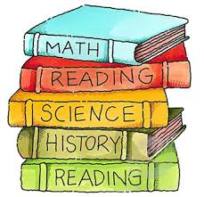
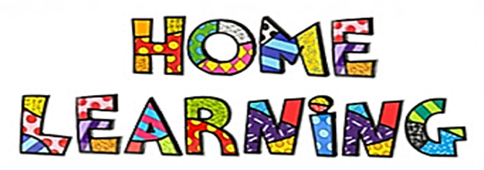
Important Note about Home Learning:
- Try your best to stay to the schedule as it will keep it feeling like a regular school day!
- Keep things you work on and bring it to school in your homework folders.
- Keep a daily reading log (write down the book title and have an adult sign next to it)
- Try new things throughout the day (there are multiple options)
- Take pictures along the way and email them to me jenna.stewart@nbed.nb.ca
Daily Schedule:
Start time 9AM.
Mindful Mornings (9am-10am) Options:
- Walk outside
- Quiet reading to self
- Colouring sheet or drawing
- Yoga: Cosmic yoga (YouTube)
Literacy (10am-11am) Options:
- Reading:
  - Storyline Online https://storylineonline.net/
  - Read to Self (book from home or library book)
  - Listen to someone else read
  - Read to someone, a pet, or stuffy.
- Writing:
  - Write a treasure hunt/ mystery story with the map writing sheet in your home learning folder.
  - Keep a daily journal: Tell me about what you did that day (exploring, school work, family time, etc). and anything happening in your life that day.
  - Tell me how to carve a Jack-O-Lantern (Use paragraph starters: First, Then, Next, After that, Finally). Use detail!
- Word Work:
  - Reading Comprehension sheets in home learning folders
  - You’re & Your sheet in home learning folders
  - Work with your spelling words Unit 4: rainbow write your words.
  - ABCYah Games: Literacy Games for grade 4 students. https://www.abcya.com/grades/4

Math (11am-12pm)
- Splashlearn: Log in and complete assignments from Ms. Stewart (focus on multiplication) https://www.splashlearn.com/signin
- ABCYah Games: Numeracy games for grade 4 students https://www.abcya.com/grades/4
- Study 3 and 4 times table facts (Yellow Sheet in home folders)
  - 3s Video: https://www.youtube.com/watch?v=70aG99v704k
  - 4s Video: https://www.youtube.com/watch?v=UJY1_fzzM6Y
- Choose a sheet from home learning Folders
- Card games
- Telling Time: Students can practice using a digital and analogue clock. https://jr.brainpop.com/math/time/timetotheminute/
- Baking/Cooking: Provides a real-life opportunity to practice fractions and step by step writing.
- Data Collection (bar graphs, line plots, pictographs: Students can ask questions such as “What is your favorite TV show?” Students may need to use technology such as a telephone or a computer to contact friends and relatives to survey.
- If you have a google account, I will attach a separate link to the Toothy Game which should work on presentation mode.
LUNCH: Enjoy a nice Health Lunch (12-1pm)
Quiet Time (1-1:30) Options:
- Reading
- Puzzles
- Nap
- Drawing
- Yoga
Creative Time/ Science/ Social Studies (1:30-2:30) Options:
- Lego
- Drawing (How to Draw on YouTube) or just draw what inspires you.
- Crafts
- Baking
- Explore something new today! Either explore outside or try something new, even exploring a new idea or understanding how something works!
- Think about an animal that might live in Canada. Do some research on what it needs to survive and what its habitat looks like. You can even create a habitat with materials from home!
- Look outside for rocks and describe them and what they look and feel like. Draw a picture to go with it.
Exercise & Fresh Air (2:30-3)
Get outside and enjoy the fresh air. Play and HAVE FUN!

