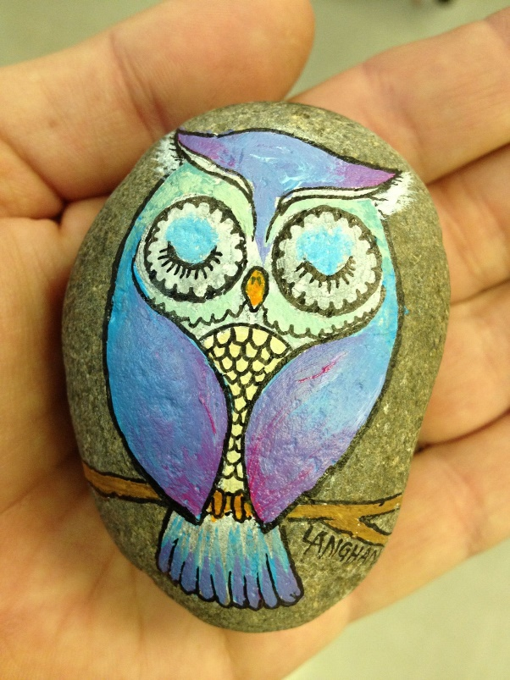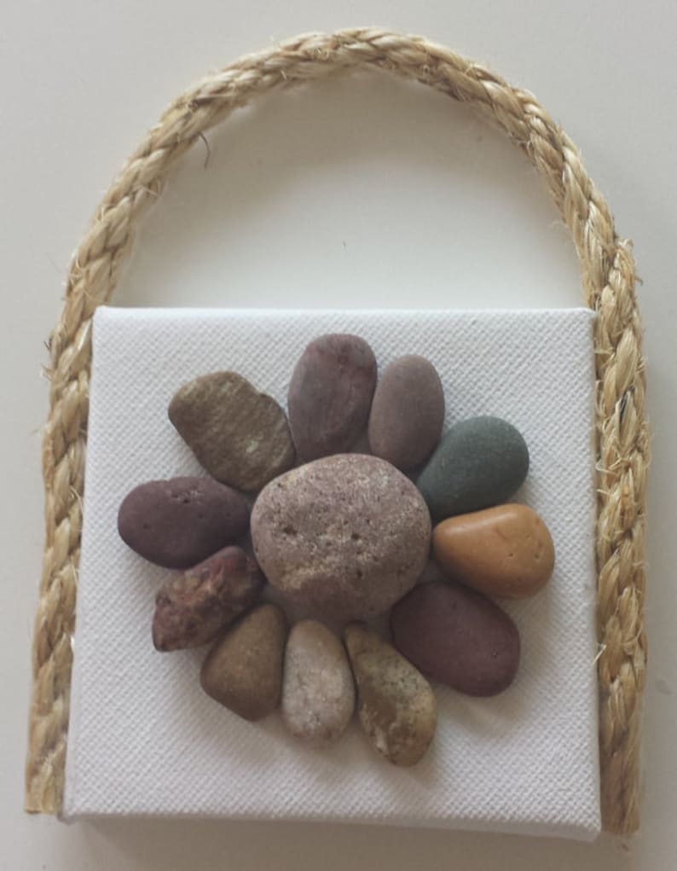**Rocks creati** **on**