Tornado in a Glass Experiment
Materials Needed:
-Water
-Liquid dish soap
-Tall glass or jar
-Stirrer (could be a pencil, straw, etc.)

Directions:
- Fill the glass with three quarters of water.
- Put a few drops of dish soap in the water.
- Hold the jar with one hand and use your other hand to stir the water quickly in a circular motion, until you see spinning bubbles.
- Remove the stirrer and observe
- Write a sentence about what you saw happening in the glass. Draw a picture to go with it!

Math

Use items around your house (ex. socks, snacks, crayons, Lego, leaves) to practice making patterns with. You can start with an AB pattern (ex. red leaf, green leaf, red leaf, green leaf…). Then try an ABB pattern (ex. red leaf, green leaf, green leaf, red leaf, green leaf, green leaf…). Finally try to make an AAB pattern (ex. red leaf, red leaf, green leaf, red leaf, red leaf, green leaf…)

Take out a piece of paper and practice doing the number of the day, just like we do in class! Today’s number of the day is 28. Remember we always show this number in ten frames, with tally marks, and as a picture. We also write the number word and what 1 more and 1 less than that number would be. See below for an example
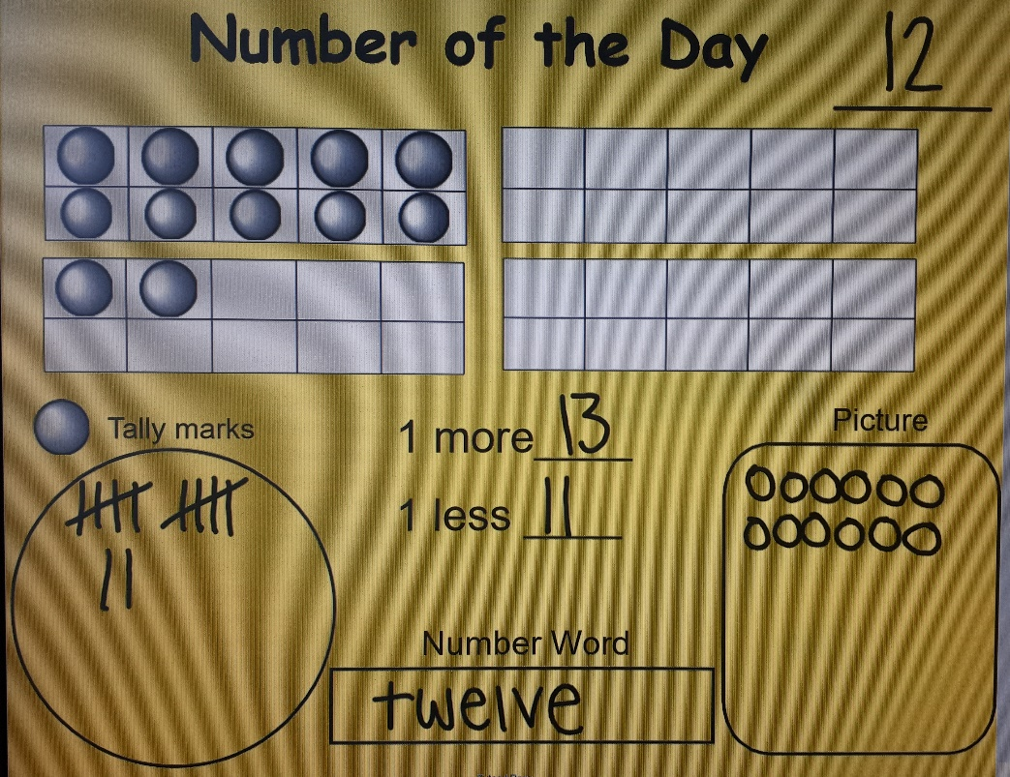

Literacy
Read a book or listen to a story on storyline online (https://storylineonline.net/). After the story, tell an adult what the best part of the book was and write a sentence about it.

