Home Learning October 6, 2021
Today for home learning we would like our students to take advantage of the beautiful weather and get outside.
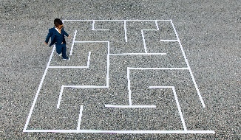
Students in Kindergarten and grade 1 have been learning how to share space with others while moving. Students in grade 2 have been working on sharing space with others while moving and avoiding objects.
Tag Games are a fun way to develop these skills and we encourage students
to play with members of their household in their own yard.
Create a simple obstacle course in your yard with things to run between, jump over, run around, crawl under or walk on. Try using skipping ropes, hockey/ringette sticks, lawn chairs, sidewalk chalk, empty water bottles.
Get outside and have some fun and be active. Please send us some pictures of what you have come up with.
