Home Learning January 11th, 2022
Remember to:
- Keep things you work on and bring it to school in your homework folders.
- Try new things throughout the day (there are multiple options).
- Students should work on the sheets posted each day.
Daily Schedule
Math  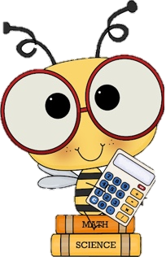 | - Number Detective: Submit your guess to me via email and I will add your name on a ticket for a draw when you return. You should submit a guess everyday and if you get it right with Friday’s clue you will receive a treat when you come back!  - Home Learning Package:  - Focus on 6 times tables (Multiply by 6s sheet & Parrot colour by numbers)  - Look over and practice your number words (thousand, hundred, twelve, etc). Write out 10 different numbers (there will be a quiz on this when you return).  - Multiplication videos:  - 6s Video: https://www.youtube.com/watch?v=zlNaIPnOZoY  - 7s Video:https://www.youtube.com/watch?v=WdF_vFAxwas&t=91s  - Splashlearn: Log in and complete assignments from Ms. Stewart https://www.splashlearn.com/signin  - If you have a google account or PowerPoint: I will attach a separate link to the Toothy Game that students can play independently.
Language Arts | - Reading:  - Read to Self for 20 minutes (book from home or guided reading book)  - Epic: https://www.getepic.com/sign-in/educator  - Classcode is: ahr8886  - Writing:  - Keep a daily writing journal: Pick one of the Winter Writing Prompts and write in your pink journal. Make sure to use your editing checklist (I will attach a link to one below). Make sure to read it over twice! Try your best to write 3 paragraphs.  - Word Work:  - Study Unit 8 spelling words (practice sheets in home learning folder).
Cross-Curricular | - French: Flora (practice songs and games flora.nbed.nb.ca)  - Drawing (How to Draw on YouTube) or just draw what inspires you.  - 2022 Worksheets in home learning package:  - Colour and write in what your goals are and your favourite part of 2021. You can cut out the numbers and glue them on construction paper (I will attach an image).
Exercise & Fresh Air | Get outside and enjoy the day!  Check out Mr. Williston & Ms. Comeau’s Teacher page

