Remember to:
- Keep things you work on and bring it to school in your homework folders.
- Try new things throughout the day (there are multiple options).
- Students should work on the sheets posted each day.
Daily Schedule
Math  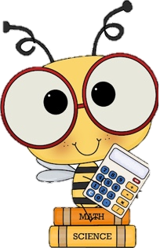 | - Number Detective: Submit your guess to me via email and I will add your name on a ticket for a draw when you return. You should submit a guess everyday and if you get it right with Friday’s clue you will receive a treat when you come back!  - Home Learning Package:  - Focus on fractions today! Colour in the fraction Sheet title “Fractions” “Part of a Whole” and “Fraction Sort” (cut and glue needed)  - Look over and practice your number words (thousand, hundred, twelve, etc). Write out 10 different numbers (there will be a quiz on this when you return).  - Splashlearn: Log in and complete assignments from Ms. Stewart https://www.splashlearn.com/signin  - If you have a google account or PowerPoint: I will attach a separate link to the Toothy Game that students can play independently.
Language Arts | - Reading:  - Read for 20 minutes  - Describe your favourite part of the book so far (in your pink duotang)  - Writing:  - Keep a daily writing journal: Pick one of the Winter Writing Prompts and write in your pink journal. Make sure to use your editing checklist (I will attach a link to one below). Make sure to read it over twice! Try your best to write 3 paragraphs.  - Word Work:  - Study Unit 8 spelling words (practice sheets in home learning folder).
Cross-Curricular | - French: Flora (practice songs and games flora.nbed.nb.ca)  - Cursive Writing Booklet (try practicing letter a and b (lowercase and uppercase)  - New Year’s Eve Word Search  - Pick a square from the Cross-Curricular Bingo attached.
Exercise & Fresh Air | Get outside and enjoy the day!  Check out Mr. Williston & Ms. Comeau’s Teacher page

