Remember to:
- Keep things you work on and bring it to school in your homework folders.
- Try new things throughout the day (there are multiple options).
- Students should work on the sheets posted each day.
Daily Schedule
Math  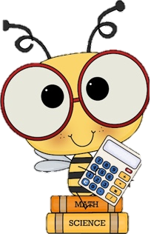 | - Number Detective: Submit your guess to me via email and you name will be entered into a draw for a prize! I will be posting a new clue everyday.  - Home Learning Package:  - Telling Time Sheet: Draw the minute and hour hands on the sheet (if not completed from Friday). Draw the hour hand in red and the minute hand in blue.  - Elapsed time sheet: complete the time past sheet about New Years.  - Additional: Splashlearn: Log in and complete assignments from Ms. Stewart https://www.splashlearn.com/signin  - If you have a google account or PowerPoint: I will attach a separate link to the Toothy Game that students can play independently.
Language Arts | - Reading:  - Read for 20 minutes. You have the option to read to a family member or a pet.  - New Year’s Resolution Reading Comprehension sheet (read the story and answer the questions that follow.  - Writing:  - Keep a daily writing journal: Pick one new topic the Winter Writing Prompts and write in your pink journal (this should be your 4th writing piece). Make sure to use your editing checklist (I will attach a link to one below). Make sure to read it over twice! Try your best to write 3 paragraphs.  - Word Work:  - Letter Mix-Up: I LOVE SNOW, make as many new words with these letters as you can (cut out the letters you will be surprised how many more words you can find by moving them around).
Cross-Curricular | - French: Flora (practice songs and games flora.nbed.nb.ca)  - Cursive Writing Booklet (try practicing letter b&c (lowercase and uppercase)  - Pick a square from the Cross-Curricular Bingo attached.
Exercise & Fresh Air | Get outside and enjoy the day!  Check out Mr. Williston & Ms. Comeau’s Teacher page

