Remember to:
- Keep things you work on and bring it to school in your homework folders.
- Try new things throughout the day (there are multiple options).
- Students should work on the sheets posted each day.
Daily Schedule
Math  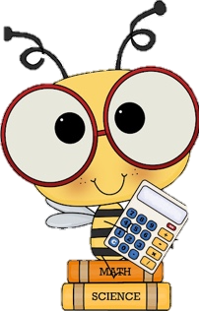 | - Number Detective: Submit your guess to me via email and you name will be entered into a draw for a prize! I will be posting a new clue everyday.  - Home Learning Package:  - Fractions of a Set: Animal sheet  - Fractions of a Set: double sided sheet  - Additional: Splashlearn: Log in and complete assignments from Ms. Stewart https://www.splashlearn.com/signin  - If you have a google account or PowerPoint: I will attach a separate link to the Toothy Game that students can play independently.
Language Arts | - Reading:  - Read for 20 minutes. You have the option to read to a family member or a pet.  - Three Bears Reading Comprehension sheet (read the story and answer the questions that follow. Write how this story would be different with a polar bear and in the Arctic)  - If you aren’t sure of the tale of Goldilocks: https://www.youtube.com/watch?v=qOJ_A5tgBKM  - Writing:  - Keep a daily writing journal: Pick one new topic the Winter Writing Prompts and write in your pink journal (this should be your 4th writing piece). Make sure to use your editing checklist (I will attach a link to one below). Make sure to read it over twice! Try your best to write 3 paragraphs.  - Word Work:  - Homophones sheet (your, you’re, one, won)
Cross-Curricular | - French: Flora (practice songs and games flora.nbed.nb.ca)  - Cursive Writing Booklet (practicing all the cursive letters in your home package (a,b,c, and d)  - Art: create something with materials from home (construction paper, new paper, magazines, tissues, cardboard, markers, glue, etc).  - SEND ME A PHOTO OF YOUR CREATION!  - Pick a square from the Cross-Curricular Bingo attached.
Exercise & Fresh Air | Get outside and enjoy the day!  Check out Mr. Williston & Ms. Comeau’s Teacher page

