Remember to:
- Keep things you work on and bring it to school in your homework folders.
- Try new things throughout the day (there are multiple options).
- Students should work on the sheets posted each day.
Daily Schedule
Math  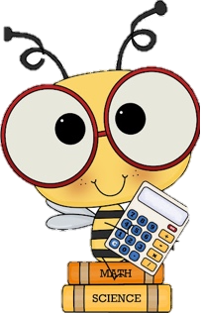 | - Number Detective: Submit your guess to me via email and if you get it right with Today’s clue you will receive a treat when you come back!  - Home Learning Package:  - Addition Sheet: double sided addition sheet  - If there are any sheets that you need a little more time with from your package you can finish it up today!  - Fractions: If you have construction paper at home you can make a pizza with different toppings (Pepperoni, green peppers, cheese, onion, pineapple, etc). Put different toppings on each slice and then write what fraction of the pizza has onions, or whatever topping you wish.  - Additional: Splashlearn: Log in and complete assignments from Ms. Stewart https://www.splashlearn.com/signin  - If you have a google account or PowerPoint: I will attach a separate link to the Toothy Game that students can play independently.
Language Arts | - Reading:  - Read for 20 minutes.  - Write the next chapter to the book you are reading. If it is a guided reading book than write what would be in the second book.  - Writing:  - 16 Writing Prompts: Keep a daily writing journal: Pick one new topic the Winter Writing Prompts and write in your pink journal. Make sure to use your editing checklist (I will attach a link to one below). Make sure to read it over twice! Try your best to write 3 paragraphs.  - Word Work:  - Practice your Unit 8 Spelling words. Rainbow write or write them with fancy letters.
Cross-Curricular | - French: Flora (practice songs and games flora.nbed.nb.ca)  - Snow Volcano: I will attach instructions to this experiment  - https://www.scholastic.com/parents/school-success/learning-toolkit-blog/snow-play-make-frozen-volcano.html#:~:text=Step%201%3A%20Pour%201%20cup,to%20form%20a%20pouring%20container.&text=Step%205%3A%20Go%20outside%20and,it%20looks%20like%20a%20volcano.  - Cursive Writing Booklet (practicing all the cursive letters in your home package (a,b,c, and d)  - Pick a square from the Cross-Curricular Bingo attached.
Exercise & Fresh Air | Get outside and enjoy the day!  Check out Mr. Williston & Ms. Comeau’s Teacher page

