French Literacy
Word work/mots frequents(15-20 per day)
Practice spelling the following words in fun and creative ways just like we do in class(mots arc-en-ciel, tic tac mots, graffiti, cursive, etc…)

New words are:
moi • du • des • quel • quelle • dans • besoin • regarde • peux • peut
-
Reading
-Lalilo website Lalilo | Online Phonics program for Distance Learning for 15-20 minutes daily. Use student in school option. Our class code is: AYKPHC. No password is required.
-Listen to a tumblebook in French (TumbleBooks - Cyber-livres pour cyber-enfants (biblioenfants.com)) Login is nblib and the password is nbschools
-Je lis je lis (https://jelis.rkpublishing.com/)
I just got a subscription to a new website for French literacy. Students all have their own user id and password. Students can record their readings and I get an alert and can listen to their reading and help them with anything they may be having difficulty with.
Writing
Write a sentence with the following words:
-besoin
-regarde
-dans
-moi
Math
Play SplashLearn Sign In for20 minutes daily. Class code is: UQZZSW and all students share the same password: left17. There are assignments that I have put on for students to complete. Students have used this site in class so they are aware how to use it.
- Use a number generator like Number Picker Wheel - Pick Random Number by Spinning or Random Number between 0 and 999 (numbergenerator.org). Say the number aloud in French.

Estimer jusqu’à 1 000
1. Selon toi, combien y a-t-il de boutons dans la grande boîte ?
Comment as-tu fait ton estimation ?
Explique ton raisonnement à l’aide d’images, de nombres ou de mots.
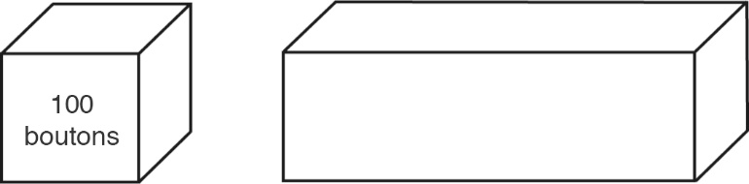
2. Quelle est la meilleure estimation du nombre de graines dans la grosse pile ? Explique ton choix.
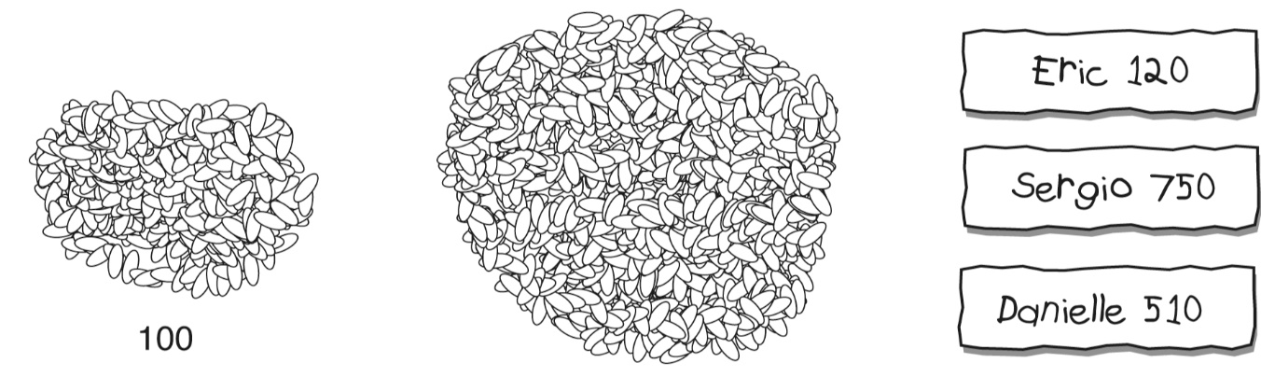

English
-Read to self (or parents, sibling….) for 15-20.
-You can also go on tumble books to listen to a book there.
Writing
I will be sending you some English spelling activities via email. If you have any questions please feel free to send me an email. Also, once your child has completed the activities please take a picture and you can send it to my email and I will check it out. Thanks and have a great day. I will post on my teacher page daily

