Good morning, Boys, Girls and Guardians,
Lesson Plan- Wednesday, November 10, 2021
On Monday, November 1, 2021, we began Home Learning. Posted below are recommendations as well as a visual schedule of what a day of At Home Learning can look like
30 Minutes of Physical Activity is encouraged and 45 minutes a day for Literacy and Numeracy are recommended for students in Grade 1.
9:00-9:30 | Soft Start (this is how we begin our day at school). Choose an activity  - Coloring/Drawing  Click on the link for step-by-step instructions on how to draw a poppy. Draw and color your poppy. Hang it in your window to show respect for the soldiers who fought for our freedom.  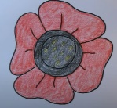  https://www.youtube.com/watch?v=fismjznSDl0
9:30-10:00 | Read the attached poem “Little Poppy”  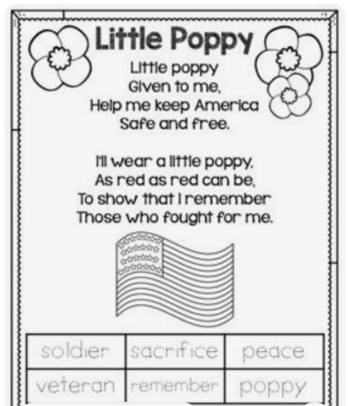  After reading the poem find the sight words me, and, can and for. Practice writing them. Discuss with an adult the meaning of the words at the bottom of the poem.
10:00-10:15 | Brain Break- “Friends of Ten”  https://www.youtube.com/watch?v=QS5w8LRnnp0
10:15-10:30 | 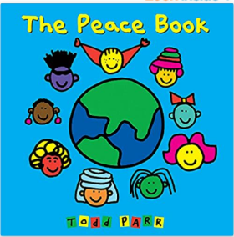  Click on the link below to listen to “The Peace Book”.  After listening to the book write a sentence about what brings you peace.  Ex: Sitting on the couch watching TV with my boy brings me peace.  https://www.youtube.com/watch?v=t3fcJ1P4OcY
10:30- 10:45 | Snack
10:45- 11:00 | Complete the math sheet below by drawing the 10 frames and poppies onto a blank page.  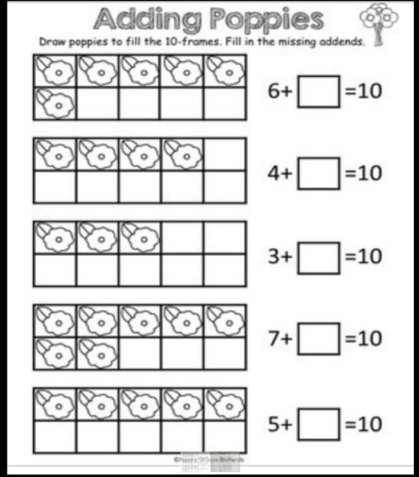
11:00- 11:15 | Login to Zorbit and work on the assigned Pattern activities – 15 minutes
11:15-12:30 | Lunch
12:30-12:45 | Practice printing your numbers 1-20. Remember, when ever you hear “teen” it’s a clue that the number begins with a “1”. EX: fourteen = 14
12:45-1:45 | Physical Education- See Mrs. Comeau’s Teacher Page for some PE activities.
- All Students have be provided with Login information to Squiggle Park and Epic(Literacy) and Splash Learn and Zorbit(Numeracy).

Parents/Guardians- Please keep all student work completed during Home Learning and send it to school with your child when we return to school base learning.

