Lesson Plan- Tuesday, November 2, 2021
Good morning, Grade One Families!
Today is Terrific Tuesday! Are you ready for home learning today?
Attached to this note is a lesson plan for you to use as a guideline, while we are at home learning. Please email me if you have any questions.
Please keep all student work completed during Home Learning and send it to school with your child when we return to school base learning. I would ask that a pencil be used when your child is completing any writing or math activities.

9:00-9:30 | Begin each day with a soft start - a simple way for students to ease into their school day work  Choose one of these activities or one of your own!  - Coloring  - Building  - A walk outside  - Help cook breakfast
9:30-9:45 | Read a book- Make it fun. Read in one of the creative/fun ways listed on one of your November Reading Bingo which has been uploaded to our teacher page.
9:45-10:00 | In your Home Learning Booklet play the games” Rainbow Letters and Read My Back” These games will help your child learn to read and write their sight words.
10:00-10:15 | Brain Break- There are great videos on You Tube and Go Noodle for brain breaks. I will post some to my teacher page but here are a few we use in the class.  Learning about Copassion  https://www.youtube.com/watch?v=oEplqZYUUvk  Melting  https://www.youtube.com/watch?v=fTzXFPh6CPI  Koo Koo Kangaroo – Milkshake  https://www.youtube.com/watch?v=Y9LLfv7yauM  Freeze Dance (they love this one!!)  https://www.youtube.com/watch?v=2UcZWXvgMZE
10:15-10:30 | Writing- In your Home Learning packet is Writing Paper with an editing checklist. Write 2-3 sentences on this paper, preferably with a pencil. Have a grown up in your house remind you about your capital letter at the beginning, printing neatly on the lines, finger spaces,  Here is a prompt for you use :  My favourite thing for supper is ……  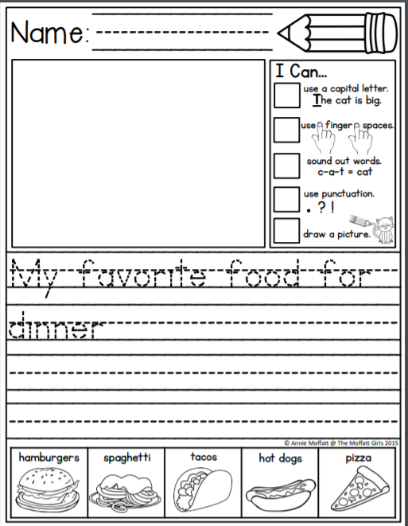
10:30- 10:45 | Snack
10:45- 11:00 | Practice counting from 0-20 and then from 20 to 0.  Count from 5 to 16  Count from 11 to 20  Count from 12 back to 4  Count from 19 back to 8  Skip count by 2’s to 20  Skip count by 5’s to 50 (or to 100 if you want to make it a challenge)  Skip count by 10’s to 100  Using your Halloween candy make the following patterns. AABA, ABC and ABBA. (ex: AABA= Twix, Twix, Aero, Twix, Twix, Twix, Aero, Twix etc.  Take a photo and email me your patterns! I will put them on my teacher page!
11:00- 11:15 | Play Memory Match. Have a grown up write the numbers 0-20 on index cards or a piece of paper will work and the same number words. (ex: 3 and three.) Turn all face down. One at a time take turns turning 2 cards over and try to match the numeral with the word.
11:15-12:30 | Lunch
12:30-12:45 | Play Zorbits on a tablet or a grown up’s phone if you are able.
12:45-1:00 | Play Squiggle Park on a tablet or a grown up’s phone if you are able.
1:00 – 1:45 | Physical Education- Go outside and play! Practice throwing a ball to someone or throw it up in the air and try to catch it! Play tag with some friends or your family. Go for a walk with a grown up. I hope you all had a good day.

