Lesson plan for November 3, 2021
9:00-9:30 | Begin each day with a soft start - a simple way for students to ease into their school day work  Choose one of these activities or one of your own!  - Coloring  - Building  - A walk outside  - Help cook breakfast
9:30-9:45 | Read one or two of your books from your home folder book- November Reading Bingo which has been uploaded to my teacher page.
9:45-10:00 | Sight word practice – go through all of the words that you know. Known sight words are words that you know in 3 seconds. After that try two new sight words that you are still practicing. Here is a fun way to practice those two new sight words:  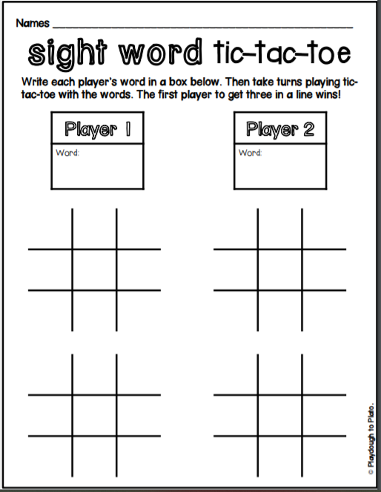  Practice these “an” family words today with the web link below  https://www.starfall.com/h/ltr-sv-a/maw-an/?sn=ltr-classic
10:00-10:15 | Brain Break- How are you feeling today? Do you need to get energized, et focused on the day, or do you need to feel a bit more relaxed? Here are some new videos for you to try that may help you!  Koo Koo Kangaroo – Wobbly Man  https://www.youtube.com/watch?v=bS7H4FbqOYQ  Go Noodle – Flow – Rainbow Breath  https://www.youtube.com/watch?v=O29e4rRMrV4
10:15-10:30 | Writing- In your Home Learning packet is Writing Paper with an editing checklist. Write 2-3 sentences on this paper, preferably with a pencil. Have a grown up in your house remind you about your capital letter at the beginning, printing neatly on the lines, and finger spaces. I have put a sample below of how you should start .  Here is the prompt for you use : Today I feel _____________ because  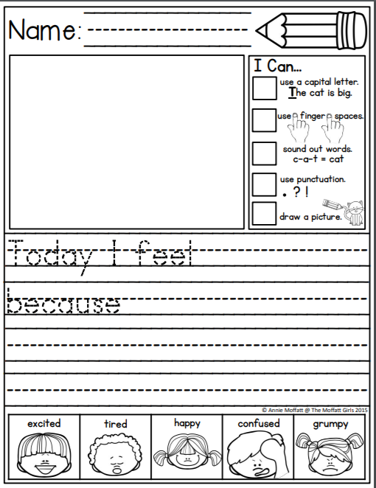  Or you can write about the idea of your choice as well . :D
10:30- 10:45 | Snack
10:45- 11:00 | Math  Practice counting from 0-20 and then from 20 to 0.  Count from 5 to 16  Count from 11 to 20  Count from 12 back to 4  Count from 19 back to 8  Skip count by 2’s to 20  Skip count by 5’s to 50 (or to 100 if you want to make it a challenge)  Skip count by 10’s to 50 (or to 100 if you want to make it a challenge again)  Here is Jack Hartman to help you with skip counting ! Click on the link below:  https://www.youtube.com/watch?v=q_yUC1NCFkE  Here is a skip counting game to play:  https://www.roomrecess.com/games/SpacePetsSkipCounting/play.html
11:00- 11:15 | Practice printing your numbers from 0 to 20. Have a grown up sit with you if possible, to help you make your numbers the proper way, remember to always try your best.
11:15-12:30 | Lunch
12:30-12:45 | Play Zorbits on a tablet or a grown up’s phone if you are able.
12:45-1:00 | Play Squiggle Park on a tablet or a grown up’s phone if you are able.
1:00 – 1:45 | Physical Education- Go to Mr. Williston’s teacher page to see the fun activities he has for you to try!

