Good morning, Boys, Girls and Guardians,
Lesson Plan- Tuesday, November 9, 2021
On Monday, November 1, 2021, we began Home Learning. Posted below are recommendations as well as a visual schedule of what a day of At Home Learning can look like.
30 minutes of Physical Activity is encouraged and 45 minutes a day for Literacy and Numeracy are recommended for students in Grade 1.
9:00-9:30 | Soft Start (this is how we begin our day at school). Choose an activity  - Coloring  - Building  - A walk outside  - Help cook breakfast
9:30-9:45 | Read a book- Make it fun. Read in one of the creative/fun ways listed on your November Reading Bingo which has been uploaded to our teacher page.  *We have assigned 2 new books for your child to read on Epic Books. Please see our Teacher Page for Epic Books login instructions.
9:45-10:00 | Literacy- Read each sentence below and then using the word list, write the sight word that correctly completes each sentence on a separate sheet of paper.  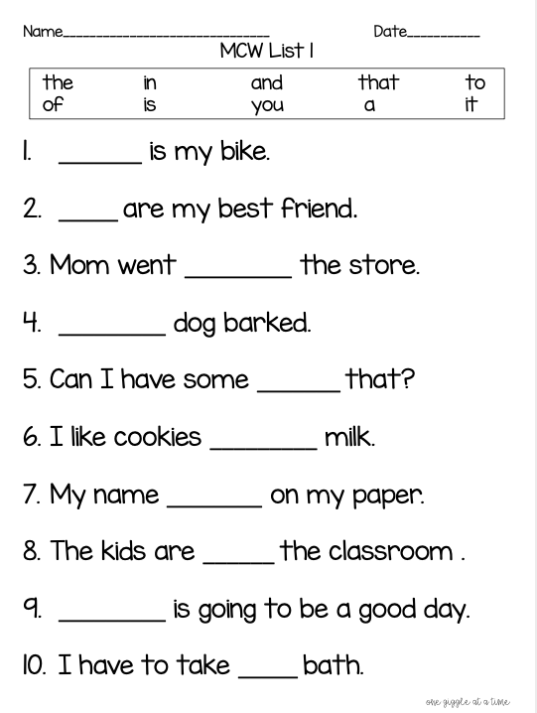
10:00-10:15 | Brain Break  Jack Hartmann’s Parts of a Sentence: https://www.youtube.com/watch?v=Qh7hCqyfaPs  Number Words Rap: https://www.youtube.com/watch?v=SzfFzJGwwZQ
10:15-10:30 | You and Your World/Literacy- Today we will continue to learn about Remembrance Day. Read “The Poppy” on the sheet below. After reading, write a sentence to answer the question, “Why should you wear a poppy in November?” If you are able to print the sheet, you may color in the poppies when you are done. If not, try to draw and color your own poppies!  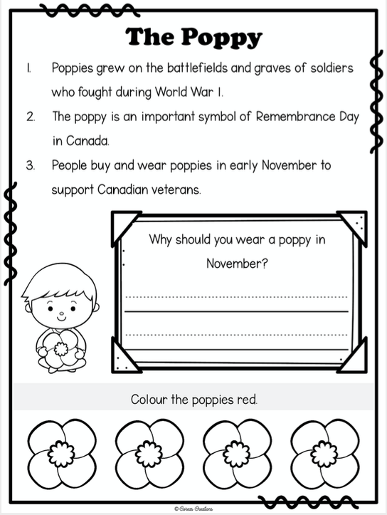
10:30- 10:45 | Snack
10:45- 11:00 | 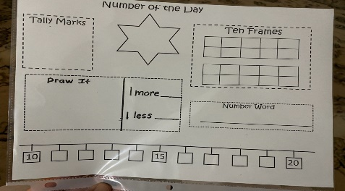  Math  Represent the number of the day in different ways. The number of the day today is 15.
11:00- 11:15 | Math  - Have a parent/guardian say a numeral from 1-10. Record the numeral on a sheet of paper. Ex. parent/guardian says “ten” and student writes “10”. Repeat with all the numerals from 1-10.  - Now try it with all the numerals from 11-20.  - Once you have written down all the numerals from 1-20, have a parent/guardian point to each of the numerals one at a time. Practice reading the numerals.
11:15-12:30 | Lunch
12:30-12:45 | Math  Login to Zorbit’s Math and work on completing your assignments
12:45-1:45 | Physical Education- See Mr. Williston’s Teacher Page for PE activities.  Music- See Mrs. Comeau’s Teacher Page for Music activities.
- All students have been provided with login information for Squiggle Park (Literacy), Splash Learn and Zorbit’s Math (Numeracy).
Parents/Guardians- Please keep all student work completed during Home Learning and send it to school with your child when we return to school base learning.

