Mme Russell | Home Learning- Wednesday January 19th
 | Warm Up: Using the calendar template in the home learning packet, write the date, the weather and the season with a white board marker. Don’t forget to say it orally
Literacy  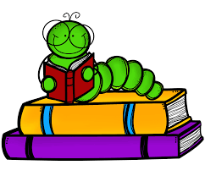 | Words: jeu, nous, vous, ballon, fête (These are new words.)  Word Work: In the word work section in your home learning packet, there is a worksheet titled, “Mots Robot”. Please put this sheet in a page protector. Using a white board marker, students will write their words of the week with square letters. Don’t forget to read the words when you are done writing them!  **I also posted a PowerPoint on the Teams page of the words of the week being used in a sentence.  Sound: M. Brun « un »  M Brun - YouTube (song)  M. Brun - YouTube (words)  After watching both videos, can you write some words that have the sound “un” on your whiteboard?  Reading: Je lis, je lis, littératie ! ONLINE (rkpublishing.com)  Three books have been assigned to each child on the Je lis! Website. Each book should be read a few times throughout the week. Please work on things like fluency, expression and volume. If you feel you are ready, you can record yourself reading and I will listen to it  Oral Activity: You are going to have ALL WEEK to complete this activity!  You are going to record a video introducing a pet that you have at your house. (If you don’t have a pet, you can do a stuffed animal or a doll.) You will be describing this pet. (i.e. name, color, size, age, what he likes etc.) I will post a video on the Teams page as an example. It does not have to be anything complicated. When you are finished, you have 3 choices. You can upload it to the Teams page, or you can send it to me privately. If you are REALLY not comfortable recording yourself, you can just write down the sentences and share it in a picture.
Math  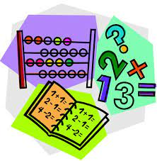 | - Play Zorbit Math for 20 minutes.  - Play subtraction war with a deck of cards. Each person will flip over 2 cards. Subtract the smaller number from the bigger number. The person with the bigger difference keeps the cards.  - Give these a try:  IXL | Subtraction with pictures | Grade 2 math  IXL | Write subtraction sentences to describe pictures - up to 18 | Grade 2 math
Exploration,  Art,  You and Your World | Les êtres vivants et non-vivants 2 - YouTube  Today you will continue working with living and non-living things. You will complete a sorting activity that was uploaded to the Teams page. You can print it out or you can just complete it on a separate piece of paper. Please divide the page in to 2 columns: être vivants et non-vivants. You can sort the photos by writing them in the correct columns.  Don’t forget to take the time for fresh air and physical activity. You can also check Mr.Williston’s Phys.ed page and Mrs. Comeau’s music page.  If you have any questions/comments/concerns, please send me an email at sara.russell@nbed.nb.ca.  Have a great day!!  **Please remember to keep all completed work for when we return to school.
Other French Learning Opportunities | Listen to French stories on Tumble Books: https://www.tumblebooks.com/  - Username: nblib password: nbschools  - Some may be a bit difficult but listening to French is important  Radio Canada Zone Jeunesse – videos and games  - https://ici.radio-canada.ca/jeunesse/scolaire  YouTube also has some songs and videos in French

