Mme Russell | Home Learning- Friday January 21st
 | Warm Up: Using the calendar template in the home learning packet, write the date, the weather and the season with a white board marker. Don’t forget to say it orally
Literacy  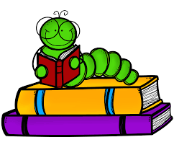 | Words: jeu, nous, vous, ballon, fête (These are new words.)  Word Work: Can you write a sentence with the words of the week? Pick two of the words for this week and write a sentence with both. If you need some help, you can listen to the PowerPoint of the words on the TEAMS page.  Sound: M. Brun « un »  M Brun - YouTube (song)  M. Brun - YouTube (words)  Reading: Je lis, je lis, littératie ! ONLINE (rkpublishing.com)  Three books have been assigned to each child on the Je lis! Website. Each book should be read a few times throughout the week. Please work on things like fluency, expression and volume. If you feel you are ready, you can record yourself reading and I will listen to it  Oral Activity: You are going to have ALL WEEK to complete this activity!  You are going to record a video introducing a pet that you have at your house. (If you don’t have a pet, you can do a stuffed animal or a doll.) You will be describing this pet. (i.e. name, color, size, age, what he likes etc.) I will post a video on the Teams page as an example. It does not have to be anything complicated. When you are finished, you have 3 choices. You can upload it to the Teams page, or you can send it to me privately. If you are REALLY not comfortable recording yourself, you can just write down the sentences and share it in a picture.
Math  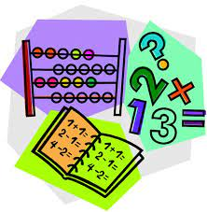 | - Play Zorbit Math for 20 minutes.  - Play a game of addition war with the deck of cards to practice addition facts to 20. All face cards are worth 10 and the A’s are worth 1. Each person flips 2 cards and adds them together. Whoever has the bigger number wins the cards. If the total is the same, then flip 2 more. The higher number always keeps the cards. Whoever wins all the cards or who has the most at the end, wins the game.  - In your Home Learning packet, there is a worksheet titled “La maison d’hiver”. Please answer the math questions with a pencil first, then color the spaces based on the code at the bottom.  - Give these a try:  IXL | Addition with pictures - sums to 20 | Grade 2 math  IXL | Ways to make a number - sums to 20 | Grade 2 math
Exploration,  Art,  You and Your World | Les Trois Petits Cochons - dessin animé en français - Conte pour enfants avec les P'tits z'Amis - YouTube  Please watch this video of the Three Little Pigs. After you watch the video, can you retell the story to someone in your family? What happened in the story? Who were the characters? What happened at the end?  Don’t forget to take the time for fresh air and physical activity. You can also check Mr.Williston’s Phys.ed page and Mrs. Comeau’s music page.  If you have any questions/comments/concerns, please send me an email at sara.russell@nbed.nb.ca.  Have a great day!!  **Please remember to keep all completed work for when we return to school.
Other French Learning Opportunities | Listen to French stories on Tumble Books: https://www.tumblebooks.com/  - Username: nblib password: nbschools  - Some may be a bit difficult but listening to French is important  Radio Canada Zone Jeunesse – videos and games  - https://ici.radio-canada.ca/jeunesse/scolaire  YouTube also has some songs and videos in French

