Mme Russell | Home Learning- Friday January 28th
 | Warm Up: Using the calendar template in the home learning packet, write the date, the weather and the season with a white board marker. Don’t forget to say it orally
Literacy  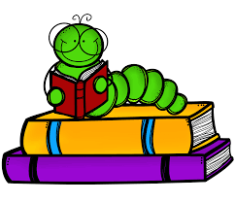 | Words: nouveau, nouvelle, toujours, sommes, peut-être (These are new words.)  Word Work: Can you write a sentence using the words of the week? Pick two from this week and use them in a sentence. If you need help, you can listen to the Powerpoint that was posted on the Teams page earlier in the week.  Sound: Agnès Agneau  Agnès Agneau - YouTube  Agnes agneau - YouTube  After watching both videos, can you make a list of words that have the sound “gn”?  Reading: Je lis, je lis, littératie ! ONLINE (rkpublishing.com)  Three books have been assigned to each child on the Je lis! Website. Each book should be read a few times throughout the week. Please work on things like fluency, expression and volume. If you feel you are ready, you can record yourself reading and I will listen to it  Oral Activity: You are going to have ALL WEEK to complete this activity!  Mon animal préféré (My Favorite Animal)- you will choose any animal and you are going to describe it. You will record a video and post it to the Teams page (or send it to me privately). Be as creative as you want. You can use a picture, a stuffed animal, or a toy. Things you will include in the description: size (taille), how many paws (pattes), color (couleur), tail (queue), ears (oreilles), how they move (déplacer), what they eat (manger), where they live (habiter). I will post a video and a written example on the Teams page.  If you don’t feel comfortable recording yourself, you can write a description and send a picture of that.
Math  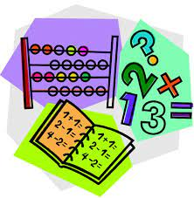 | - Play Zorbit Math for 20 minutes.  - Play a game of “Turnover and add” with a deck of cards. One person flips over 2 cards. The first person to add them together and say the answer gets to keep the cards. All face cards are worth 10.  - In your home learning packet, there is a worksheet titled “Les additions en folie”. Please do the addition questions in pencil first. When you are sure the answers, are correct, you can color the spaces based on the code provided.  - Give these a try:  IXL | Addition sentences: which is true? | Grade 2 math  IXL | Ways to make a number - sums to 20 | Grade 2 math
Exploration,  Art,  You and Your World | Today we are going to begin exploring different animal habitats. (Les habitats) Please watch this video:  Science pour la classe : Les habitats - YouTube  Can you name different habitats? What animals live in these habitats? What animal habitats are in Canada? What animals do we see in Canada?  Don’t forget to take the time for fresh air and physical activity. You can also check Mr.Williston’s Phys.ed page and Mrs. Comeau’s music page.  If you have any questions/comments/concerns, please send me an email at sara.russell@nbed.nb.ca.  Have a great day!!  **Please remember to keep all completed work for when we return to school.
Other French Learning Opportunities | Listen to French stories on Tumble Books: https://www.tumblebooks.com/  - Username: nblib password: nbschools  - Some may be a bit difficult but listening to French is important  Radio Canada Zone Jeunesse – videos and games  - https://ici.radio-canada.ca/jeunesse/scolaire  YouTube also has some songs and videos in French

