Mme Russell | Home Learning- Thursday January 20th
 | Warm Up: Using the calendar template in the home learning packet, write the date, the weather and the season with a white board marker. Don’t forget to say it orally
Literacy  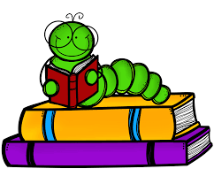 | Words: jeu, nous, vous, ballon, fête (These are new words.)  Word Work: Today we are going to build the words using lego, playdoh, blocks, letter tiles, magnetic letters, or anything else you have in your house. You can post a picture on the Teams page when they are done  Sound: M. Brun « un »  M Brun - YouTube (song)  M. Brun - YouTube (words)  After watching both videos, can you write some words that have the sound “un” on your whiteboard?  Reading: Je lis, je lis, littératie ! ONLINE (rkpublishing.com)  Three books have been assigned to each child on the Je lis! Website. Each book should be read a few times throughout the week. Please work on things like fluency, expression and volume. If you feel you are ready, you can record yourself reading and I will listen to it  Oral Activity: You are going to have ALL WEEK to complete this activity!  You are going to record a video introducing a pet that you have at your house. (If you don’t have a pet, you can do a stuffed animal or a doll.) You will be describing this pet. (i.e. name, color, size, age, what he likes etc.) I will post a video on the Teams page as an example. It does not have to be anything complicated. When you are finished, you have 3 choices. You can upload it to the Teams page, or you can send it to me privately. If you are REALLY not comfortable recording yourself, you can just write down the sentences and share it in a picture.
Math  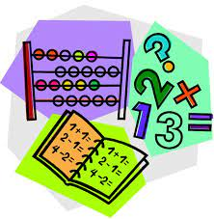 | - Play Zorbit Math for 20 minutes.  - Please take 2 handfuls of small objects you can find around the house. Some examples could be cheerios, beans, small lego pieces, counters, buttons, coins, or anything else you can think of. You count these objects by putting them in groups of ten. When you are finished, how many groups of 10 do you have? How many do you have left over? How many in total? Write down your answers on a white board. Repeat this activity 3 more times.  - Give this a try:  IXL | Skip-count by tens | Grade 2 math
Exploration,  Art,  You and Your World | Art: How to draw a snowflake  Comment dessiner de la NEIGE très facile | Dessin Pour Enfant - YouTube  Please watch this directed drawing video about how to draw a snowflake. You will need a piece of paper, a pencil and something to color with. They use a marker in the video. I would suggest using a pencil and then outlining it in black when you are finished. I would love to see pictures of the finished product  Don’t forget to take the time for fresh air and physical activity. You can also check Mr.Williston’s Phys.ed page and Mrs. Comeau’s music page.  If you have any questions/comments/concerns, please send me an email at sara.russell@nbed.nb.ca.  Have a great day!!  **Please remember to keep all completed work for when we return to school.
Other French Learning Opportunities | Listen to French stories on Tumble Books: https://www.tumblebooks.com/  - Username: nblib password: nbschools  - Some may be a bit difficult but listening to French is important  Radio Canada Zone Jeunesse – videos and games  - https://ici.radio-canada.ca/jeunesse/scolaire  YouTube also has some songs and videos in French

