Mme Russell | Home Learning- Monday January 24th
 | Warm Up: Using the calendar template in the home learning packet, write the date, the weather and the season with a white board marker. Don’t forget to say it orally
Literacy  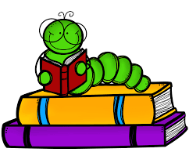 | Words: nouveau, nouvelle, toujours, sommes, peut-être (These are new words.)  A video of the words being read will be uploaded to the Teams page. Watch the video 3 times. On the third time, mute the video and try to read the words yourself.  Sound: Agnès Agneau  Agnès Agneau - YouTube  A copy of the poem has been uploaded to the Teams page. Can you find all of the “gn’s”  Reading: Je lis, je lis, littératie ! ONLINE (rkpublishing.com)  Three books have been assigned to each child on the Je lis! Website. Each book should be read a few times throughout the week. Please work on things like fluency, expression and volume. If you feel you are ready, you can record yourself reading and I will listen to it  Oral Activity: You are going to have ALL WEEK to complete this activity!  Mon animal préféré (My Favorite Animal)- you will choose any animal and you are going to describe it. You will record a video and post it to the Teams page (or send it to me privately). Be as creative as you want. You can use a picture, a stuffed animal, or a toy. Things you will include in the description: size (taille), how many paws (pattes), color (couleur), tail (queue), ears (oreilles), how they move (déplacer), what they eat (manger), where they live (habiter). I will post a video and a written example on the Teams page.  If you don’t feel comfortable recording yourself, you can write a description and send a picture of that.
Math  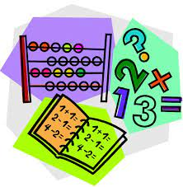 | - Play Zorbit Math for 20 minutes.  - Today we will be working on representing numbers. Please take the number 61 and represent it as many ways as possible. Some suggestions are base ten blocks, ten frames, tally marks, money, dice, words, equations, odd/even etc. Please use the whiteboard in your learning packet.  - In your learning packet, there is a worksheet that says “Dénombrer” in the top left corner. You will represent each number using tens (dizaines) and ones (unités).  - Give this a try  IXL | Place value models - tens and ones | Grade 2 math
Exploration,  Art,  You and Your World | Les animaux sauvages pour les enfants - Vocabulaire pour les enfants - YouTube  Apprendre les animaux de la ferme - Apprendre le Français - YouTube  Les reptiles pour enfants - Les animaux vertébrés - Les sciences naturelles pour enfants - YouTube  Here are a few videos about animals. As you watch the videos, think about what the animals look like (physical characteristics). What color are they (couleur)? How many paws do they have (pattes)? Do they have a tail (queue)? What size are they (taille)? How do they move? (déplacer)  Don’t forget to take the time for fresh air and physical activity. You can also check Mr.Williston’s Phys.ed page and Mrs. Comeau’s music page.  If you have any questions/comments/concerns, please send me an email at sara.russell@nbed.nb.ca.  Have a great day!!  **Please remember to keep all completed work for when we return to school.
Other French Learning Opportunities | Listen to French stories on Tumble Books: https://www.tumblebooks.com/  - Username: nblib password: nbschools  - Some may be a bit difficult but listening to French is important  Radio Canada Zone Jeunesse – videos and games  - https://ici.radio-canada.ca/jeunesse/scolaire  YouTube also has some songs and videos in French

