Mme Russell | Home Learning- Thursday January 27th
 | Warm Up: Using the calendar template in the home learning packet, write the date, the weather and the season with a white board marker. Don’t forget to say it orally
Literacy  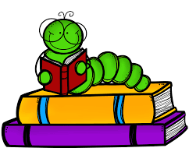 | Words: nouveau, nouvelle, toujours, sommes, peut-être (These are new words.)  Word Work: Today we are going to build the words using lego, playdoh, blocks, letter tiles, magnetic letters, or anything else you have in your house. You can post a picture on the Teams page when they are done  Sound: Agnès Agneau  Agnès Agneau - YouTube  Agnes agneau - YouTube  After watching both videos, can you make a list of words that have the sound “gn”?  Reading: Je lis, je lis, littératie ! ONLINE (rkpublishing.com)  Three books have been assigned to each child on the Je lis! Website. Each book should be read a few times throughout the week. Please work on things like fluency, expression and volume. If you feel you are ready, you can record yourself reading and I will listen to it  Oral Activity: You are going to have ALL WEEK to complete this activity!  Mon animal préféré (My Favorite Animal)- you will choose any animal and you are going to describe it. You will record a video and post it to the Teams page (or send it to me privately). Be as creative as you want. You can use a picture, a stuffed animal, or a toy. Things you will include in the description: size (taille), how many paws (pattes), color (couleur), tail (queue), ears (oreilles), how they move (déplacer), what they eat (manger), where they live (habiter). I will post a video and a written example on the Teams page.  If you don’t feel comfortable recording yourself, you can write a description and send a picture of that.
Math  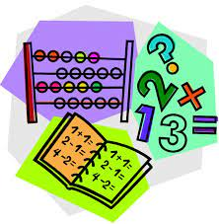 | - Play Zorbit Math for 20 minutes.  - Using your hundreds chart and white board marker in your home learning packet, you will count by 5s. Starting at 5, color in each number as you count by 5s to 100. What do you notice about the pattern? Will you say the number 78? 56? 25? 90? 23? Why or why not?  - In your home learning packet, there is a worksheet titled, “Écris les nombres manquants”. You will do BOTH sides. First side, you will be counting by 2s and the second side you will be counting by 5s.  - Give this a try:  IXL | Skip-count by fives | Grade 2 math
Exploration,  Art,  You and Your World | Art:  Comment dessiner OLAF très facile | Dessin Pour Enfant - YouTube  Please watch this directed drawing video about how to draw Olaf. You will need a piece of paper, a pencil and something to color with. They use a marker in the video. I would suggest using a pencil and then outlining it in black when you are finished. I would love to see pictures of the finished product  Don’t forget to take the time for fresh air and physical activity. You can also check Mr.Williston’s Phys.ed page and Mrs. Comeau’s music page.  If you have any questions/comments/concerns, please send me an email at sara.russell@nbed.nb.ca.  Have a great day!!  **Please remember to keep all completed work for when we return to school.
Other French Learning Opportunities | Listen to French stories on Tumble Books: https://www.tumblebooks.com/  - Username: nblib password: nbschools  - Some may be a bit difficult but listening to French is important  Radio Canada Zone Jeunesse – videos and games  - https://ici.radio-canada.ca/jeunesse/scolaire  YouTube also has some songs and videos in French

