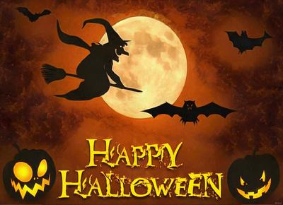
Tuesday, October 25, 2022
Dear Parents:
I wanted to create this newsletter to update everyone on what has been happening in our classroom. It seems impossible to believe that November is right around the corner!
Everyone needs to come to school wearing their black outfits for the Black Light dress rehearsal tomorrow, even their socks will need to be black! They will also need to pack a lunch for both days and are welcome to bring quiet activities for the day such as card games, books and coloring. We will be at JMH for the whole day and they will not be able to call home if they forget anything due to the time constraints! The students are quite excited to perform!
On Friday, we will be having a Halloween Dance in the gym. They can wear their costume and bring in a treat to share on that day.
In Math, we did work on large numbers in September. This month we have been working on solving addition and subtraction equations with a missing number, long division and memorizing mental math facts. We will be having a test on equations, large numbers, long division questions and a mental math component with their 2s and 3s timetables. We have also worked on estimation strategies as well as various units of measurement.
Our “Halloween Around the World” project has been our focus over the past 2 weeks in English Language Arts. Most students have chosen to create a Power Point presentation to show what they have learned, while others are using trifold and poster boards. Presentations will begin Friday and continue next week. The groups are working in pairs or individually to answer the who, what, when, where why and how questions about the country of their choice and the way they celebrate.
Civilizations of the past is the theme for Social Studies. The students all presented their precious objects and now we are reading and discussing topics that encompass archeology, excavation sites, artefacts, and where to find information about the past. The trip to the museum will happen soon. We delayed it with time devoted to the Black Light Performance.
In French Language Arts, we started to work on writing “Un démarche à suivre” which uses transition words and imperative verbs to explain to someone how to follow a recipe or learn to ride a bike. Centers will be focused on listening, writing and orally explaining how to do things while following the necessary steps. The time spent on centers is to help them write their final assessment independently. The Bingo sheet that I had provided to support at-home reading should be completed by next week. I will be sending home usernames and passwords by next week to “Je lis, je lis” to encourage students to move forward in their learning.
The Health Unit that we will be covering next will be about making healthy choices and taking care of your body in various ways. I will always include some yoga, meditation and mindfulness practice to help them when they are feeling like anxiety and stress are taking over!
Our shrunken apple heads turned out creepily and we also created pastel monsters. Art is a wonderful way to help students relieve anxiety as well! I try to introduce various mediums throughout the year so that they are exposed to new things that they might even like to try at home!

I hope this information has been helpful! If you have any questions do not hesitate to reach out!

Mme. Lydia Georgiadis
Grade 5 French Immersion
King Street School

