April Newsletter
King Street Elementary School

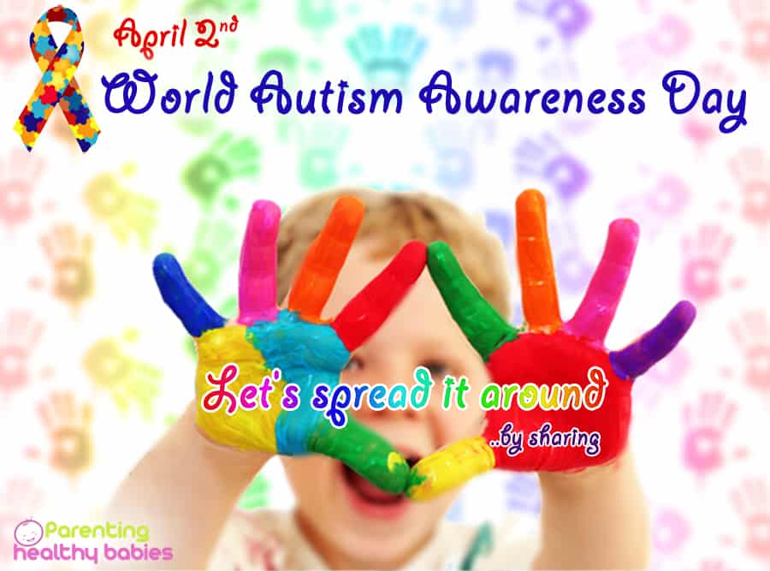
DATES TO REMEMBER
April 5 – NO School – Parent Teacher/PD
April 19 – NO School – Good Friday
April 22 – NO School – Easter Monday
May 2 & 3 – NO School – NBTA Council Days)
May 20 – NO School – Victoria Day
June 21 – Last Day of classes before Summer Break

************************************
Blue Shirt Day

World Autism Awareness Day is a day when people wear mainly a Blue shirt to raise awareness of people living with autism spectrum disorder. We will celebrate on Tuesday, April 2. We ask that students wear their favorite Blue Shirt in support of this day!!!

Music Festival
Monday, April 15 @ JMH
9:50 – KSE Primary Choir (Gr. 1 & 2)
11:50 – KSE Gr. 3-5 Choir
Tuesday, April 16 @ JMH
10:00 – Recorder Group – Gr. 4 (Prince & Williston)
10:35 – Square Dance – Gr. 4 Hosford
Thursday, April 18 @ King St Elem
9:00 – 12:00 – Solo Speech Arts
Students have individual times
It is important that you arrive approximately 15 mins
ahead of the scheduled time.
Spell-a-Thon begins on Tuesday, April 23!! Memo to follow.
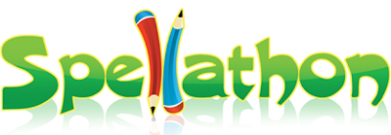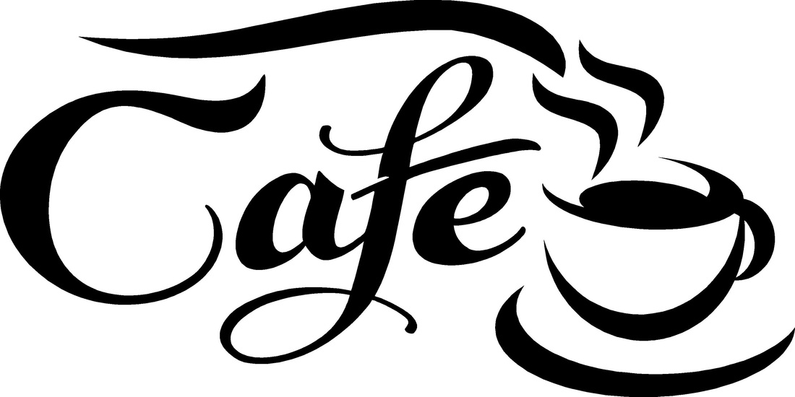
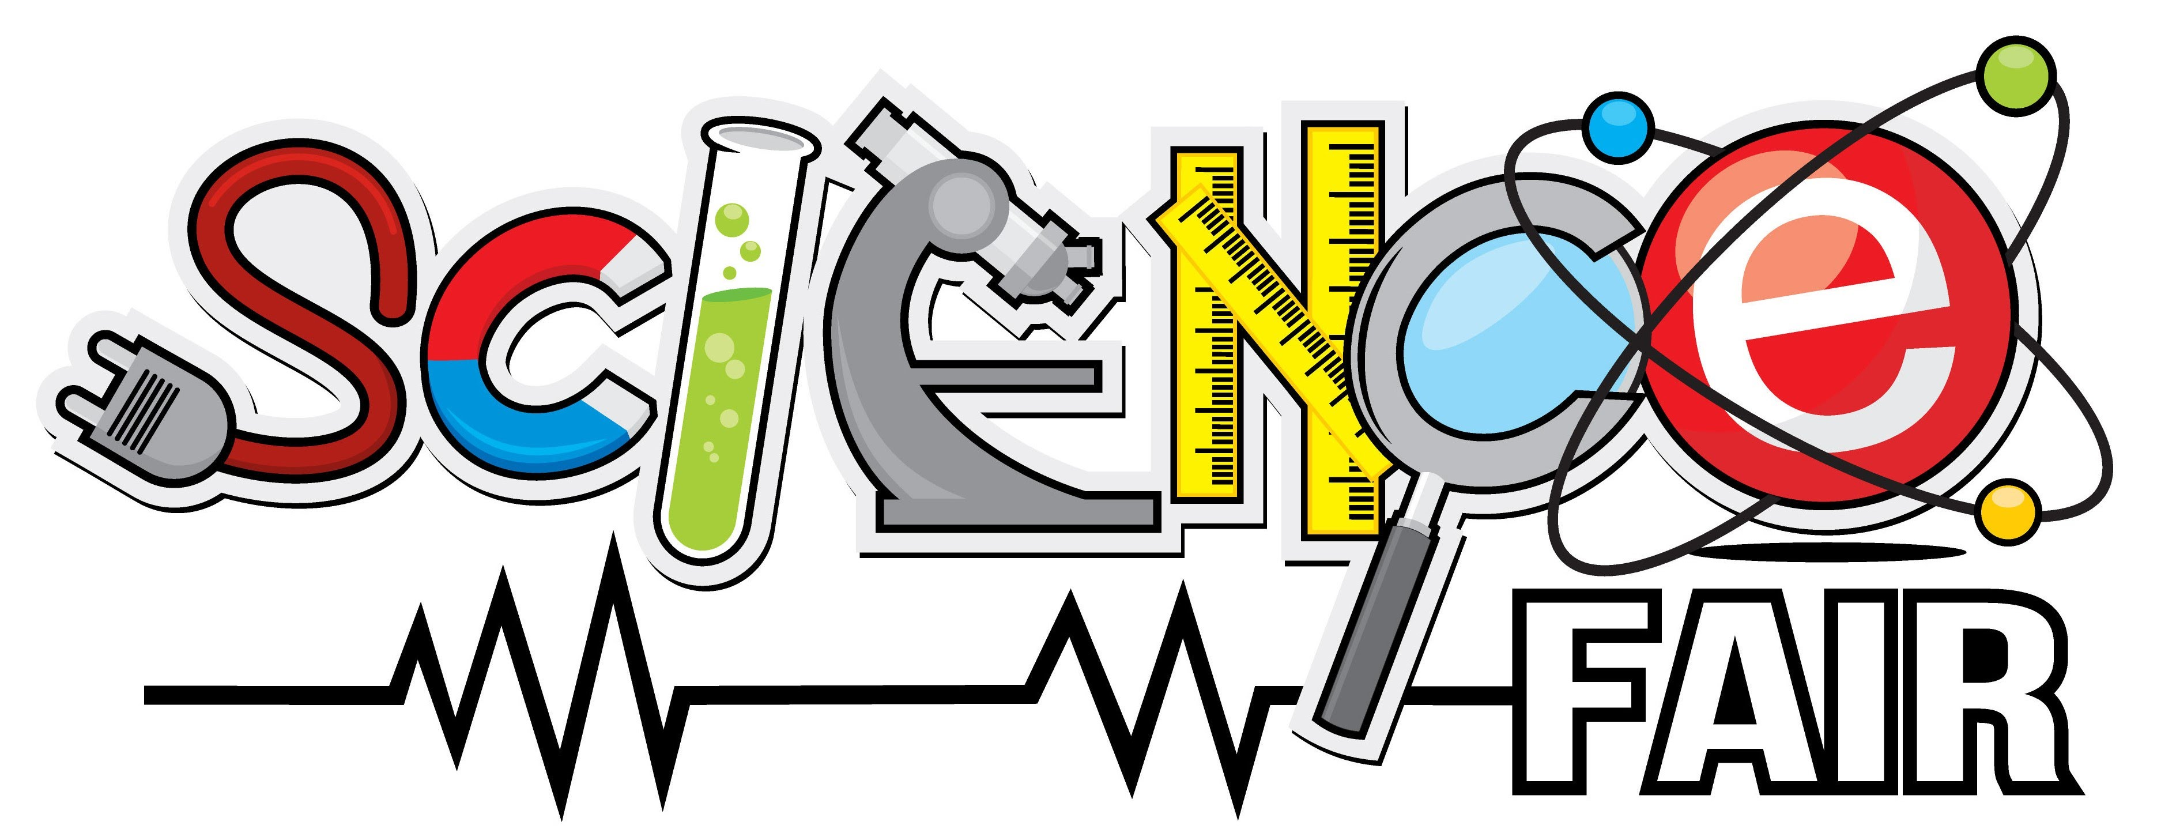
Eye Glasses
--------------------------
We are partnering up with Douglastown Lions Club and will be collecting used eye glasses (frames only or lenses are accepted also) the month of April. The students are asked to bring them into their homeroom teacher. The homeroom with the most eye glasses at the end of April will get a Pizza Party sponsored by Douglastown Lions Club!!!
Report Cards
Report cards will go home on Tuesday, April 2
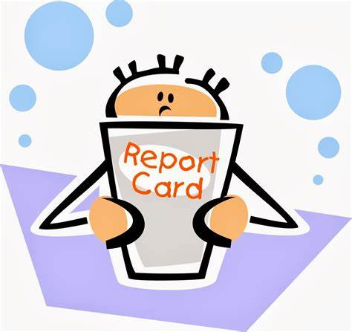

Parent Teacher Interviews

Thursday, April 4 – 6:00 – 7:30pm
Friday, April 5 – 9 – 11:30am
Please note that students are NOT to attend the Parent/Teacher appointment unless arranged by their teacher.

