Carla Doyle
Is our
Principal of the Day!!
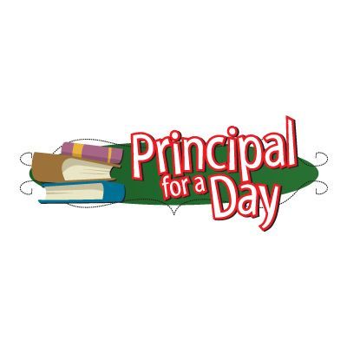

Here are her 3 Rules for Wednesday, Dec. 12:
- P.J’s for the day
- You can bring technology
- NO Homework

