MEMO
King Street Elementary
December 11, 2017

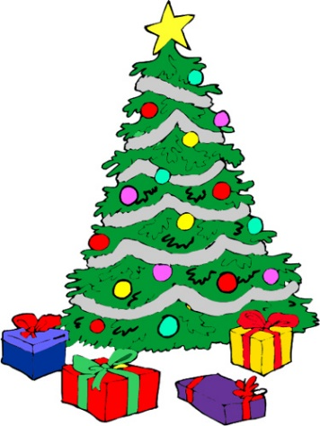
- KSE Christmas Concert is on Tuesday, December 12, K-2 @ 9:15am and Grade 3-5 @ 12:45pm. Storm day will Wednesday, December 13.
- Our Christmas Dinner is being sponsored by local businesses and we are asking parents to notify their child’s homeroom teacher if your child will not be eating dinner. The cafeteria will not be serving any other meal or Grab n Go on Thursday, Dec. 14, so please pack your child a snack and lunch.

Our King Street Elementary Christmas CD’s are ready for pre-ordering.
Please return bottom portion with money to your child’s homeroom teacher by Friday, December 15.
--------------------------------------------------------------------------------
King Street Elementary Christmas CD $5.00 each

Name: ________________________________
Homeroom: _____________________________
_______ CD’s x $5.00 each = $_________ (enclosed)

