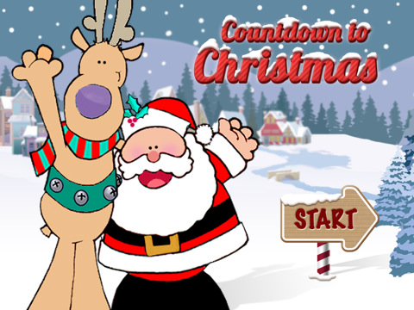
At
King Street
Elementary

King Street Elem will celebrate our countdown to Christmas the week of Dec. 17 – 21.

Monday, Dec. 17 – King St Pride (wear your favorite KSE shirt, purple or gold shirt)
Tuesday, Dec. 18 – Wear your favorite Christmas sweater!
Wednesday, Dec. 19 – Bring your favorite non-perishable food item to donate to our local Food Bank.
Thursday, Dec. 20 – Wear Red, Green or White to support peace and goodwill over Christmas.
Friday, Dec. 21 – Come to school in your favorite Pajama’s to enjoy our special event in the afternoon!!!!

