**Memo**

King Street Elementary

**November 15, 2017**

**DROP OFFS**

Please note that there is absolutely **No Parking** in the Drop-off Loop in the morning between 7:50am and 8:30am. We are having complaints from other parents that this is causing some delays for them to get to work on time. Pull up, say good bye and Pull away.

[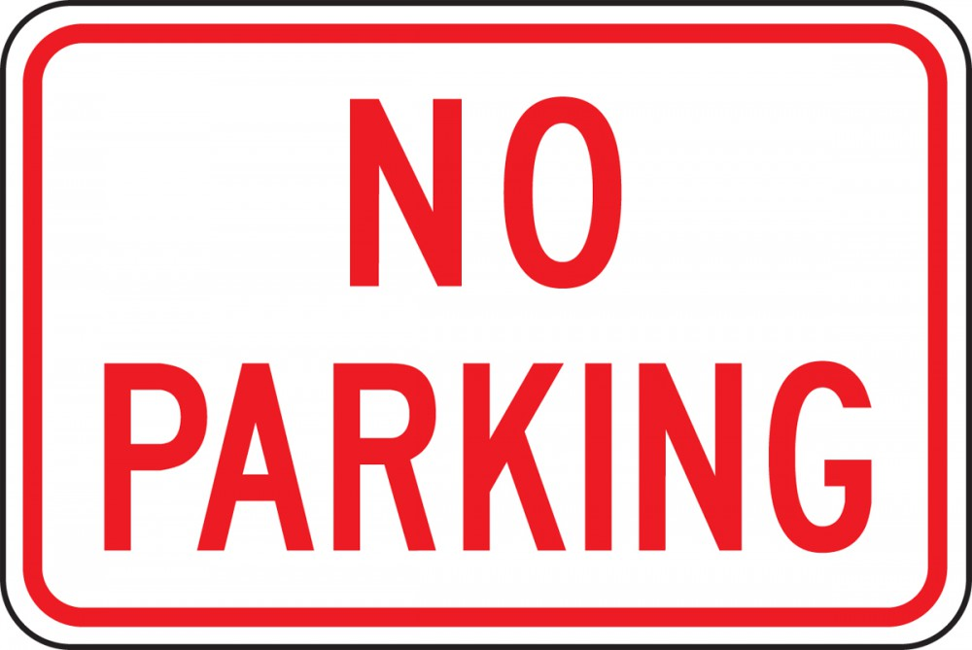](https://www.accuform.com/traffic-sign/no-parking-signs-FRP156)

If you need to escort your child to their classroom or visit with their teacher. Please park in the parking lot. **Do Not Park in the Drop-off Loop.**

Also, Do Not walk through the Loop, please use the provided sidewalk.

Safety First at King Street Elementary School

Thank you for your cooperation.

Paula and Jacqueline

**RETAKES**

Out photographer is back!! **Retakes** and **Sibling**



Picture Retake Day

Oct. 17

Wednesday, Oct. 17

[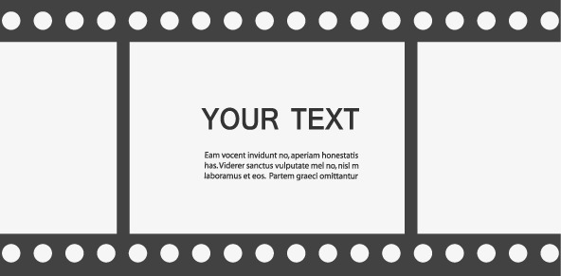](https://www.google.ca/url?sa=i&rct=j&q=&esrc=s&source=images&cd=&cad=rja&uact=8&ved=2ahUKEwix2KqLp97dAhUY24MKHUpSBIwQjRx6BAgBEAU&url=https://pngtree.com/freepng/black-border-tape_2463371.html&psig=AOvVaw2n6GkmvdRnV_dLyrlZjtez&ust=1538244933211994)

**Photos** will be on Wednesday, Oct. 17.

**Please fill in the slip below if you wish to have Sibling Photos done. Otherwise they will not be taken. Please return Wednesday.**

**-------------------------------------------------------------------------------------------------------------------------------**

**RETAKES**

Student Name: _________________________________ Grade: _________

Siblings: _______________________________________ Grade: _________

_______________________________________ Grade: _________

_______________________________________ Grade: _________